Contents
HEPATITIS B 5
HEPATITIS C 8
HIV 29
HAE 37
IPF/PAH 38
NASH 40
RHEUMATOLOGY 44
RARE DISEASES 50
ARTICLES 55

CANCER

American Society of Hematology (ASH) 2019
Clinical Practice Utilization and Outcomes with Rasburicase Vs Allopurinol for Patients at High Risk of Tumor Lysis Syndrome  Authors: Janna Radtchenko, Daniel Lyons, Yvonne Barnes, Scott Milligan, and Edward Drea  DOI: 10.1182/blood-2019-124319  Blood 134(Supplement_1): 2203-2203  Abstract accepted at 61st American Society of Hematology, 2019 December 7-10; Orlando, Florida |  | 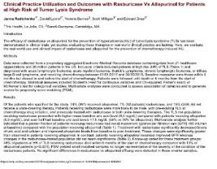  ABSTRACT

HEMOPHILIA

Haemophilia the Journal of the World Federation of Hemophilia
Effects of PK-guided prophylaxis on clinical outcomes and FVIII consumption for patients with moderate to severe Haemophilia A  Authors: Young, G, Callaghan, MU, Balasa, V, et al.  DOI: https://doi.org/10.1111/hae.14826  Published in Haemophilia the Journal of the World Federation of Hemophilia. August 8, 2023 |  | 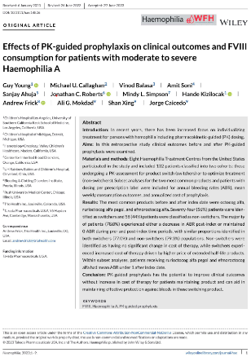  MANUSCRIPT

American Thrombosis & Hemostasis Network (ATHN) 2022
Effects of Pharmacokinetic Assessment on Clinical Outcomes for Patients with Moderate to Severe Hemophilia A  Authors: Guy Young, Michael Callaghan, Vinod Balasa, Amit Soni, Sanjay Ahuja, Jonathan C. Roberts, Mindy L. Simpson, Andrew Frick, Ali G. Mokdad, Shan Xing, and Jorge Caicedo  Poster presented at: ATHN Data Summit, 2022 Oct 19-21; London, England, U.K. |  | 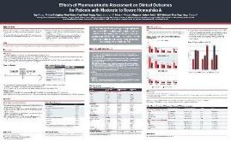  POSTER

International Society on Thrombosis and Hemostasis (ISTH) 2022
Effects of Pharmacokinetic Assessment on FVIII Consumption and Estimated Costs for Patients with Moderate to Severe Hemophilia A  Authors: Guy Young, Michael Callaghan, Vinod Balasa, Amit Soni, Sanjay Ahuja, Jonathan C. Roberts, Mindy L. Simpson, Andrew Frick, Ali G. Mokdad, Shan Xing, and Jorge Caicedo  International Society on Thrombosis and Haemostasis 2022; 2022 July 9-13: Abstract PB0689  Poster presented at: 30th Congress of the International Society on Thrombosis and Haemostasis, 2022 July 9-13; London, England, U.K. |  | 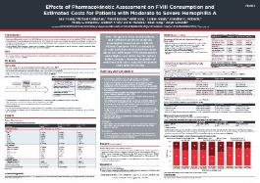  POSTER
Effects of Pharmacokinetic Assessment on Clinical Outcomes for Patients with Moderate to Severe Hemophilia A  Authors: Guy Young, Michael Callaghan, Vinod Balasa, Amit Soni, Sanjay Ahuja, Jonathan C. Roberts, Mindy L. Simpson, Andrew Frick, Ali G. Mokdad, Shan Xing, and Jorge Caicedo  International Society on Thrombosis and Haemostasis 2022; 2022 July 9-13: Abstract PB0688  Poster presented at: 30th Congress of the International Society on Thrombosis and Haemostasis, 2022 July 9-13; London, England, U.K. |  | 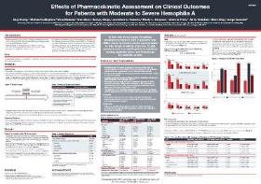  POSTER
Real-World Study of Rurioctocog Alfa Pegol and Emicizumab in US Clinical Practice Among Patients with Hemophilia A  Authors: Shawn X. Sun, Andrew Frick, Vinod Balasa, and Jonathan C. Roberts  DOI: 10.1080/17474086.2022.2112171  Published in: Expert Review of Hematology- Online Access: August 2022 |  | 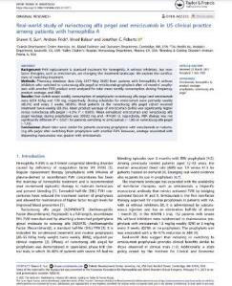  MANUSCRIPT

American Society of Hematology (ASH) 2021
A Retrospective Descriptive Study on the Effectiveness and Usage of Emicizumab and Antihemophilic Factor (recombinant), Fc Fusion Protein in Patients with Hemophilia A in the US  Authors: Alex Cockerham, Amanda Wilson, Andrew Frick, and Pronabesh  Dasmahapatra  DOI: 10.1182/blood-2021-148325  Poster presented at: 63rd American Society of Hematology, 2021 December 11-14; Atlanta, Georgia |  | 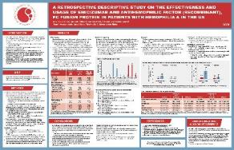  POSTER

Academy of Managed Care Pharmacy (AMCP) 2021 VIRTUAL
A Retrospective Study of Rurioctocog Alfa Pegol and Emicizumab Wastage, Consumption, and Costs in US Clinical Practice Among Patients with Hemophilia A  Authors: Shawn X. Sun, Andrew Frick  DOI: 10.18553/jmcp.2021.27.4-a.s1  Journal of Managed Care + Specialty Pharmacy 2021 Apr; 27(4-a Suppl): S47-D17  Poster presented at: AMCP Managed Care and Specialty Pharmacy Annual Meeting, 2021 Apr 12-16 and published in Journal of Managed Care + Specialty Pharmacy |  | 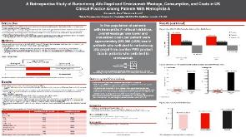  POSTER

European Association for Haemophilia and Allied Disorders (EAHAD) 2021 - VIRTUAL
A Retrospective Study of the Impact of Switching Patients with Haemophilia A to Rurioctocog Alfa Pegol or Emicizumab in US Practice  Authors: Shawn X. Sun, Andrew Frick  DOI: 10.1111/hae.14236: ABS039  ePoster presented at: European Association for Haemophilia and Allied Disorders and published in the Wiley Online Library online; 2021 February 3-5 |  |  | 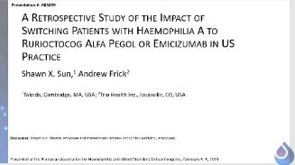  POSTER

International Society on Thrombosis and Haemostasis (ISTH) 2020 - VIRTUAL
Real-World Outcomes before and after Switching from Standard Half-Life Factor VIII to Rurioctocog Alfa Pegol in the United States  Authors: Shawn X. Sun and Scott Milligan  Res Pract Thromb Haemost. 2020; 4 (Suppl 1).  ePoster presented at: Virtual Congress and published online only as an addendum supplement to the ISTH open access journal, Research and Practice in Thrombosis and Haemostasis (RPTH), 2020 July 12-14 |  |  | 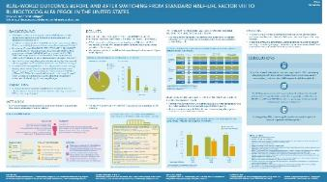  POSTER
A Retrospective, Observational Study using Specialty Pharmacy Data of Rurioctocog Alfa Pegol Use in the United States  Authors: Louis Aledort, MD, Scott Milligan, PhD, Maureen Watt, MSc, and Jason Booth, MPH  DOI: 10.18553/jmcp.2020.26.4.492  J Manag Care Spec Pharam, 2020 Apr;26(4):492-503.  Published in: Journal of Managed Care & Specialty Pharmacy (JMCP): April 2020 |  |  | 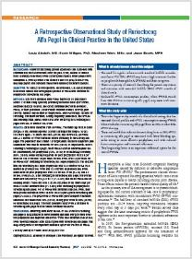  MANUSCRIPT

American Society of Hematology (ASH) 2019
Real-world, Age-Stratified FVIII Consumption and Bleed Outcomes Before and After Switching to Rurioctocog Alfa Pegol in a Retrospective, Observational Study Using US Specialty Pharmacy Data  Authors: Maureen Watt, Scott Milligan  DOI: 10.1182/blood-2019-124101  Blood (2019) 134(Supplement_1): 2411  Poster presented at: 61st American Society of Hematology, 2019 December 7-10; Orlando, Florida |  |  | 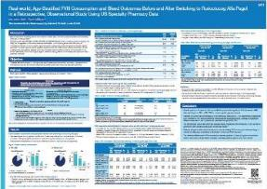  POSTER

International Society on Thrombosis and Haemostasis (ISTH) 2019
A Retrospective, Observational Study using Specialty Pharmacy data of Rurioctocog Alfa Pegol Use in the United States  Authors: Maureen Watt and Scott Milligan  DOI: 10.1002/rth2.12229  Res Pract Thromb Haemost. 2019; 3 (Suppl 1): PB0702  Poster presented at: International Society on Thrombosis and Haemostasis Meeting, 2019 July 6-10; Melbourne, Australia |  | 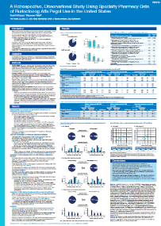  POSTER

Academy of Managed Care Pharmacy (AMCP) 2018
Retrospective, Observational Study of BAX 855 in Clinical Practice in the United States  Authors: J. Booth, M. Watt, S. Milligan, and L. Aledort.  DOI: 10.18553/jmcp.2018.24.4-a.s1  AMCP Managed Care & Specialty Pharmacy 2018; 24, No.4-a: D7  Poster presented at: AMCP Managed Care and Specialty Pharmacy Annual Meeting, 2018 Apr 23-26; Boston, MA |  | 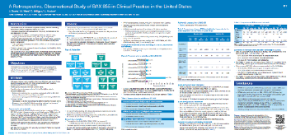  POSTER

HEPATITIS B
First-Line Therapies for Hepatitis B in the United States: A 3-year Prospective and Multicenter Real-World Study after Approval of Tenofovir Alafenamide  Authors: Calvin Q. Pan, Nezam H. Afdhal, Victor Ankoma-Sey, Ho Bae, Michael P. Curry, Douglas Dieterich, Lynn Frazier, Andrew Frick, Hie-Won Hann, W. Ray Kim, Paul Kwo, Scott Milligan, Myron J. Tong, and K. Rajender Reddy  DOI: 10.1002/hep4.1964  Published in: Hepatology Communications: Online April 21, 2022 |  | 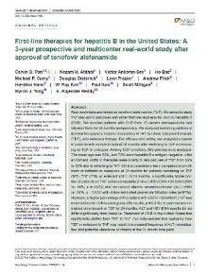  MANUSCRIPT

The European Association for the Study of the Liver (EASL) 2020 – VIRTUAL
Longer-Term Experience with Tenofovir Alafenamide (TAF) in HBV-Infected Patients; Changes in eGFR, FIB4, ALT, and DNA Suppression  Authors: Michael Curry, Ho Bae, Douglas Dieterich, Victor Ankoma-Sey, Calvin Pan, Hie-Won Hann, Myron Tong, W. Ray Kim, Paul Kwo, Lynn Frazier, Kimmi Cox, Scott Milligan, and Nezam Afdhal  Journal of Hepatology. August 2020; 73 (suppl 1): Abstract #SAT457  Poster presented at: The Digital International Liver Congress 2020; 2020 Aug 27-29 |  | 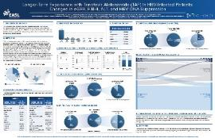  POSTER
Tenofovir Alafenamide (TAF) Adoption in HBV-Infected Populations; Assessment of Care in US Clinical Practice  Authors: Michael Curry, Ho Bae, Douglas Dieterich, Victor Ankoma-Sey, Rajender Reddy, Calvin Pan, Hie-Won Hann, Myron Tong, W. Ray Kim, Paul Kwo, Lynn Frazier, Kimmi Cox, Scott Milligan, and Nezam Afdhal  Journal of Hepatology. August 2020; 73 (suppl 1): Abstract #SAT448  Poster presented at: The Digital International Liver Congress 2020; 2020 Aug 27-29 |  | 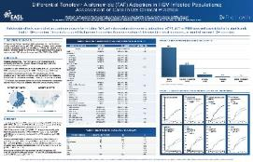  POSTER

International Society for Pharmacoeconomics and Outcomes Research (ISPOR) 2020 – VIRTUAL
Hepatitis B Treatment Patterns in US Clinical Care Following Tenofovir Alafenamide (TAF) Approval  Authors: Dr. Michael P. Curry, Dr. Ho S Bae, Dr. Douglas T Dieterich, Dr. Victor AnkomaSey, Dr. K Rajender Reddy, MD, FAASLD, Prof. Calvin Q. Pan, Dr. Hie-Won L Hann, Dr. Myron J Tong, Dr. W. Ray Kim, MD, MBA, FAASLD9, Dr. Paul Y Kwo, MD, Mrs. Lynn Frazier, Ms. Kimmi Cox, Dr. Scott Milligan, and Nezam H Afdhal  DOI: 10.1016/j.jval.2020.04.484  Poster presented at: VIRTUAL ISPOR 2020 May 15-20; Published in Value in Health and ISPOR site |  | 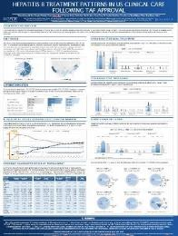  POSTER

The American Association for the Study of Liver Diseases (AASLD) 2019
Differential Tenofovir Alafenamide (TAF) Adoption in HBV-Infected Populations; Assessment of Care in US Clinical Practice  Authors: Michael Curry, Ho Bae, Douglas Dieterich, Victor Ankoma-Sey, K. Rajender Reddy, Calvin Pan, Hie-Won Hann, Myron Tong, W. Ray Kim, Paul Kwo, Lynn Frazier, Kimmi Cox, Scott Milligan, and Nezam Afdhal  Journal of Hepatology. October 2019; 70 (suppl 1): Abstract #486  Poster presented at: The Liver Meeting. 70th Annual Meeting of the American Association for the Study of Liver Diseases; 2019 Nov 8-12; Boston, MA |  | 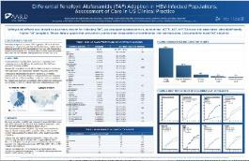  POSTER
Longer-Term Experience with Tenofovir Alafenamide (TAF) in HBV-Infected Patients; Changes in eGFR, FIB-4, ALT, and HBV DNA Suppression  Authors: K. Rajender Reddy, Michael Curry, Ho Bae, Douglas Dieterich, Victor Ankoma-Sey, Calvin Pan, Hie-Won Hann, Myron Tong, W. Ray Kim, Paul Kwo, Lynn Frazier, Kimmi Cox, Scott Milligan, and Nezam Afdhal  Journal of Hepatology. October 2019; 70 (suppl 1): Abstract #487  Poster presented at: The Liver Meeting. 70th Annual Meeting of the American Association for the Study of Liver Diseases; 2019 Nov 8-12; Boston, MA |  | 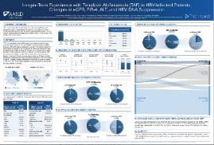  POSTER

International Society for Pharmacoeconomics and Outcomes Research (ISPOR) 2019
Clinical Practice Experience with Tenofovir Alafenamide (TAF) for Treatment of Hepatitis B in the US  Authors: Michael Curry, Ho Bae, Douglas Dieterich, Victor Ankoma-Sey, K. Rajender Reddy, Calvin Pan, Hie-Won Hann, Myron Tong, W. Ray Kim, Paul Kwo, Lynn Frazier, Scott Milligan, Janna Radtchenko, and Nezam Afdhal  DOI: 10.1016/j.jval.2019.04.883  Poster presented at: ISPOR 2019 Conference; 2019 May 18-22; New Orleans, LA |  | 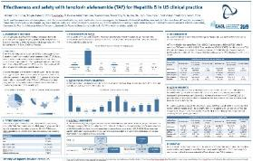  POSTER

he European Association for the Study of the Liver (EASL) 2019
Effectiveness and Safety with Tenofovir Alafenamide (TAF) for Hepatitis B in US Clinical Practice  Authors: Michael Curry, Ho Bae, Douglas Dieterich, Victor Ankoma-Sey, K. Rajender Reddy, Calvin Pan, Hie-Won Hann, Myron Tong, W Ray Kim, Paul Kwo, Lynn Frazier, Scott Milligan, Keith Spitz, and Nezam Afdhal  DOI: 10.1016/S0618-8278(19)30912-0  Poster presented at: The International Liver Congress. 54th Annual Meeting of the European Association for the Study of the Liver; 2019 Apr 10-14; Vienna, Austria |  | 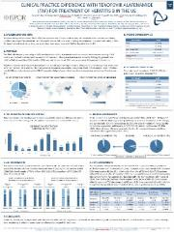  POSTER

Asian Pacific Association for the Study of the Liver (APASL) 2019
Effectiveness and Safety with Tenofovir Alafenamide (TAF) for Hepatitis B in Patients of Asian Race in US Clinical Practice  Authors: Michael Curry, Ho Bae, Douglas Dieterich, Victor Ankoma-Sey, K. Rajender Reddy, Calvin Pan, Hie-Won Hann, Myron Tong, W Ray Kim, Paul Kwo, Lynn Frazier, Scott Milligan, Keith Spitz, and Nezam Afdhal.  DOI: 10.1007/s12072-019-09936-5: Abstract#627  Oral presented at: APASL 2019. 28th Annual Conference of the Asian Pacific Association for the Study of Liver (APASL); 2019 Feb 20-24; Manila, Philippines |  | 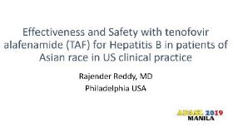  ORAL  PRESENTATION

The American Association for the Study of Liver Diseases (AASLD) 2018
Treatment of Hepatitis B in the US: Real-World Evidence from the TRIO Network  Authors: Ho Bae, Michael Curry, Douglas Dieterich, Victor Ankoma-Sey, K. Rajender Reddy, Calvin Pan, Hie-Won Hann, Myron Tong, W. Ray Kim, Paul Kwo, Lynn Frazier, Scott Milligan, and Nezam Afdhal.  Journal of Hepatology. October 2018; 68 (suppl 1): Abstract #445  Poster presented at: The Liver Meeting. 69th Annual Meeting of the American Association for the Study of Liver Diseases; 2018 Nov 9-13; Washington, DC |  |  |  | 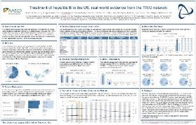  POSTER
Early Adoption of Tenofovir Alafenamide (TAF) for Hepatitis B in US Clinical Practice: Real-World Evidence from the TRIO Network  Authors: Michael Curry, Ho Bae, Douglas Dieterich, Victor Ankoma-Sey, K. Rajender Reddy, Calvin Pan, Hie-Won Hann, Myron Tong, W. Ray Kim, Paul Kwo, Lynn Frazier, Scott Milligan, and Nezam Afdhal  Journal of Hepatology. October 2018; 68 (suppl 1): Abstract #423  Poster presented at: The Liver Meeting. 69th Annual Meeting of the American Association for the Study of Liver Diseases; 2018 Nov 9-13; Washington, DC |  |  |  | 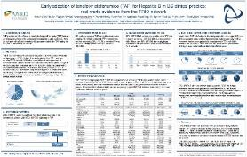  POSTER

HEPATITIS C

The European Association for the Study of the Liver (EASL) 2022
Changing HCV Patient Profiles: Insights From a Large Multinational Real-World Sofosbuvir/Velpatasvir (SOF/VEL) Dataset  Authors: A Mangia, S Fagiuoli, V Di Marco, S Shafran, M Khalili, S Milligan, G Papatheodoridis, D Ouzan, S Rosati, A Ramji, E Teti, M Garcia-Retortillo, F Andres, Perez Hernandez, A Wong, C Fraser, S Rodriguez-Tajes, E Jimenez Mutiloa, LE Morano Amado, J O'Loan, F Campanale, G Macedo, M Milella, C Brixko, M Buti, MF Guerra Veloz, R Ranieri, S Borgia, A Bascia, CM Fernandez Rodriguez, B Conway, V de Ledinghen, M Fenech, P Ryan, I Maida, A Martins, S Scherbakovsky, I Ntalla, C Hernandez, K Vanstraelen, and J Turnes  The International Liver Congress 2022; 2022 June 22-26  Poster presented at: The International Liver Congress 2022; 2022 June 22-26; London, United Kingdom |  |  |  | 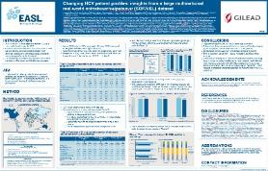  POSTER
Global Real-World Evidence of Sofosbuvir/Velpatasvir as a Highly Effective Treatment and Elimination Tool in People with Hepatitis C Infection Experiencing Mental Health Disorders  Authors: Heiner Wedemeyer, Vito Di Marco, Montserrat Garcia-Retortillo, Elisabetta Teti, Chris Fraser, Luis Enrique Morano Amado, Sergio Rodriguez-Tajes, Silvia Acosta-Lopez, Joss O’Loan, Michele Milella, Maria Buti, Maria Fernanda Guerra-Veloz, Alnoor Ramji, Mary Fenech, Alexandra Martins, Sergio M. Borgia, Kim Vanstraelen, Michael Mertens, Candido Hernandez, Ianna Ntalla, Heribert Ramroth, and Scott Milligan  DOI: 10.3390/v14112493  Published in: Viruses- Online Access: November 2022 |  |  |  | 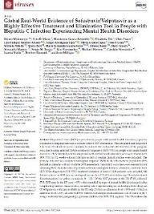  MANUSCRIPT

Global Hepatitis Summit (GHS) 2020/2021
Multinational Evaluation of Comedication and Drug-drug Interactions in Hepatitis C Patients Treated with Pangenotypic Direct-acting Antivirals  Authors: Stefano Fagiouli, Scott Milligan, Juan Turnés, Alessandra Mangia, Andreas Hintz, Nicole Wick, Antoni Sicras, Luca DegliEsposti, Frank Tacke, Ramón Morillo, GemaAlvarez Nieto, GeroNiess, Stacey Scherbakovsky, MarinelaMéndez, Hsin-Jung Lin, Kim Vanstraelen, Candido Hernandez, and Tim Umland  Poster presented at: Global Hepatitis Summit 2020/2021- The 17th International Symposium on Viral Hepatitis and Liver Disease (ISVHLD); 2021 June 18-20 |  |  |  | 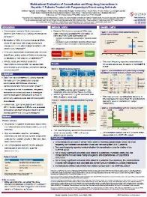  POSTER
Is the Age of Hepatitis C Patients Influencing Rapid Direct-acting Antiviral Treatment Start? Results from a Large Multinational Real-world Dataset  Authors: Juan Turnés, Alessandra Mangia, Mandana Khalili, Scott Milligan, Stefano Fagiuoli, Vito Di Marco, George Papatheodoridis, Stanislas Pol, Silvia Rosati, AlnoorRamji, Elisabetta Teti, Lisa Barrett, Montserrat Garcia-Retortillo, Francisco Pérez Hernández, Alexander Wong, Chris Fraser, Sergio Rodriguez-Tajes, Elena Jiménez Mutilo, Luis Morano, Joss O’Loan, Francesca Campanale, Guilherme Macedo, Michele Milella, Christian Brixko, Maria Buti, Maria Fernanda Guerra Veloz, Roberto Ranieri, Sergio Borgia, Annalisa Bascià, ConradoM Fernandez-Rodriguez, Brian Conway, Victor De Lédinghen, Mary Fenech, Pablo Ryan, Ivana Maida, Alexandra Martins, Ioanna Ntalla, Hsin-Jung Lin, Candido Hernandez, Kim Vanstraelen, Stacey Scherbakovsky, and Stephen D Shafran  Global Hepatitis Summit 2020/2021; 2021 June 18-20  Poster presented at: Global Hepatitis Summit 2020/2021- The 17th International Symposium on Viral Hepatitis and Liver Disease (ISVHLD); 2021 June 18-20 |  |  |  | 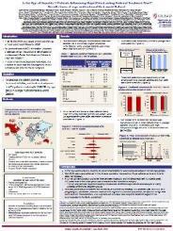  POSTER
Is the Gender of Hepatitis C Patients Influencing Rapid Direct-acting Antiviral Treatment Start? Results from a Large Multinational Real-world Dataset  Authors: Alessandra Mangia, Silvia Rosati, Lisa Barrett, ElisabettaTeti, Montserrat GarciaRetortillo, Elena Jiménez Mutilo, Francesca Campanale, Maria Buti, Maria Fernanda Guerra Veloz, Annalisa Bascià, Mary Fenech, Ivana Maida, Alexandra Martins, Juan Turnés, Scott Milligan, Stefano Fagiuoli, Vito Di Marco, Stephen D Shafran, George Papatheodoridis, Denis Ouzan, Alnoor Ramji, Francisco Pérez Hernández, Alexander Wong, Chris Fraser, Sergio Rodriguez-Tajes, Luis Morano, Joss O’Loan, Guilherme Macedo, Michele Milella, Christian Brixko, Roberto Ranieri, Sergio Borgia, ConradoM Fernandez-Rodriguez, Brian Conway, Victor De Lédinghen, Pablo Ryan, Stacey Scherbakovsky, Hsin-Jung Lin, Kim Vanstraelen, Ioanna Ntalla, Candido Hernandez, and Mandana Khalili  Global Hepatitis Summit 2020/2021; 2021 June 18-20  Poster presented at: Global Hepatitis Summit 2020/2021- The 17th International Symposium on Viral Hepatitis and Liver Disease (ISVHLD); 2021 June 18-20 |  |  |  | 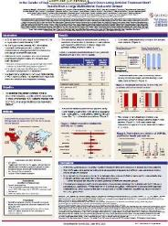  POSTER

Spanish Association for the Study of the Liver (AEEH) 2021- VIRTUAL
Eficacia de sofosbuvir/velpatasvir (SOF/VEL) en pacientes con infección crónica por VHC y trastornos psiquiátricos: resultados en práctica clínica real en 6 países  Authors: García-Retortillo M, Milligan S, Barrett L, Teti E, Wedemeyer H, Fraser C, Morano L, Rodríguez-Tajes S, Acosta-López S, O’Loan J, Milella M, Buti M, Guerra Veloz MF, Ramji A, Fernández-Rodríguez CM, Martins Figueiredo L, Fenech M, Jiménez Mutiloa E, Macedo G, Maida I, Ryan P, Campanale F, Bascia A, Conway B, Ranieri R, Borgia S, De Lédinghen V, Mangia A, Mertens M, Vanstraelen K, Ntalla I, Hernández-López C, and Di Marco V  Gastroenterol Hepatol. 2021; 44 Supl Congr 2: 32-118: Abstract #64  ePoster presented at: The 46th Annual Spanish Association For the Study of the Liver; 2021 June 14-16 |  |  |  | 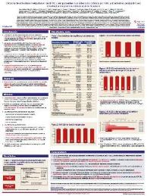  POSTER
Prevalence of Drug-Drug Interactions with Pangenotypic Direct-Acting Antivirals for Hepatitis C and Real-World Care Management in the United States: A Retrospective Observational Study  Authors: Michael P Curry, MD, Steven L Flamm, MD, Scott Milligan, PhD, Naoky Tsai, MD, Nicole Wick, AS, Zobair Younossi, MD, and Nezam H Afdhal, MD  DOI: 10.18553/jmcp.2021.20550  Published in: Journal of Managed Care + Specialty Pharmacy: June, 202 |  |  |  | 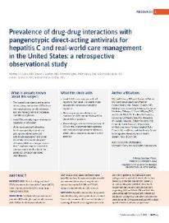  MANUSCRIPT

The American Association for the Study of Liver Diseases (AASLD) 2020 – VIRTUAL
Effectiveness of Sofosbuvir/Velpatasvir (SOF/VEL) in Patients with Chronic HCV Infection and Mental Health Disorders: Real-World Care Management from 8 Countries  Authors: Milligan S, Barrett L, Teti E, Garcia-Retortillo M, Wedemeyer H, Fraser C, Morano L, Rodriguez-Tajes S, Acosta-Lopez S, O’Loan J, Milella M, Buti M, Guerra Veloz MF, Ramji A, Fernandez-Rodriguez CM, Martins Figueiredo L, Fenech M, Jimenez Mutiloa E, Macedo G, Maida I, Ryan P, Campanale F, Bascia A, Conway B, Ranieri R, Borgia S, De Ledinghen V, Mangia A, Mertens M, Vanstraelen K, Ntalla I, Hernandez-Lopez C, and Di Marco V  Journal of Hepatology. November 2020; 72 (suppl 1): Abstract #905  Poster presented at: The Liver Meeting Digital Experience: American Association for the Study of Liver Diseases; 2020 Nov 13-16 |  |  | 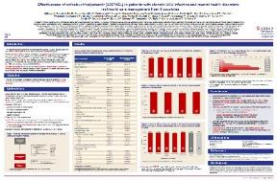  POSTER

The European Association for the Study of the Liver (EASL) 2020 - VIRTUAL
Drug-Drug Interactions (DDIs) with Pangenotypic Direct-Acting Antivirals (DAAs) in Patients with Hepatitis C; Understanding the Populations at Risk and Real-World Care Management  Authors: Michael Curry, Naoky Tsai, Bruce Bacon, Steven Flamm, Zobair Younossi, Scott Milligan, Nicole Wick, and Nezam Afdhal  Journal of Hepatology. August 2020; 73 (suppl 1): Abstract #THU435  Poster presented at: The Digital International Liver Congress 2020; 2020 Aug 27-29 |  |  | 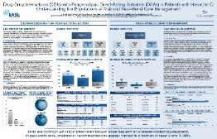  POSTER
Pangenotypic Therapies Glecaprevir-Pibrentasvir (G-P) and Sofosbuvir-Velpatasvir Voxilaprevir (S-V-V) After Failure with Interferon (IFN)-Free Direct-Acting Antiviral (DAA) Treatment for Hepatitis C  Authors: Steven Flamm, Naoky Tsai, Bruce Bacon, Michael Curry, Scott Milligan, Nicole Wick, Zobair Younossi, and Nezam Afdhal  Journal of Hepatology. August 2020; 73 (suppl 1): Abstract #SAT387  Poster presented at: The Digital International Liver Congress 2020; 2020 Aug 27-29 |  |  | 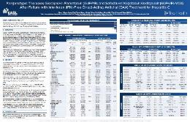  POSTER

International Society for Pharmacoeconomics and Outcomes Research (ISPOR) 2020 – VIRTUAL
Real-World Effectiveness of Hepatitis C Virus (HCV) Treatment with Direct-Acting Antivirals (DAA) in Populations with Fatty Liver/Non-Alcoholic Steatohepatitis (FL/NASH), Decompensated Cirrhosis (DCC), Hepatocellular Carcinoma (HCC), and/or Post Liver Transplant (PTX)  Authors: Zobair Younossi, Bruce Bacon, Michael Curry, Steven Flamm, Andrew Frick, Scott Milligan, Janna Radtchenko, Naoky Tsai, and Nezam Afdhal  DOI: 10.1016/j.jval.2020.04.478  Poster presented at: Virtual ISPOR 2020 May 15-20; Published in Value in Health and ISPOR site |  |  |  | 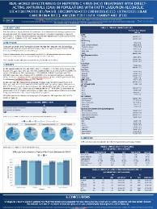  POSTER
Real-World Effectiveness of Direct-Acting Antivirals (DAA) in Young Adult (18-25) and Elderly (80+) Populations with Hepatitis C (HCV)  Authors: Naoky Tsai, Bruce Bacon, Michael Curry, Steven Flamm, Andrew Frick, Scott Milligan, Janna Radtchenko, Zobair Younossi, and Nezam Afdhal  DOI: 10.1016/j.jval.2020.04.483  Poster presented at: Virtual ISPOR 2020 May 15-20; Published in Value in Health and ISPOR site |  |  |  | 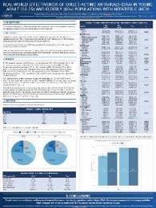  POSTER
Global Real-World Evidence of Sofosbuvir/Velpatasvir as a Simple, Effective HCV Treatment: Analysis of 5552 Patients from 12 Cohorts  Authors: Alessandra Mangia, Scott Milligan, Mandana Khalili, Stefano Fagiuoli, Stephen D. Shafran, Fabrice Carrat, Denis Ouzan, George Papatheodoridis, Alnoor Ramji, Sergio M. Borgia, Heiner Wedemeyer, Ruggero Losappio, Francisco Perez-Hernandez, Nicole Wick, Robert S. Brown Jr, Pietro Lampertico, Karen Doucette, Ioanna Ntalla, Heribert Ramroth, Michael Mertens, Kim Vanstraelen, and Juan Turnes  DOI: 10.1111/liv.14537  Published in: Liver International: May 25, 2020 |  |  |  | 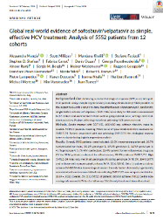  MANUSCRIPT
Effectiveness of 8-Week Glecaprevir/Pibrentasvir for Treatment-Naïve, Compensated Cirrhotic Patients with Chronic Hepatitis C Infection  Authors: Steven L. Flamm, Jens Kort, Steven E. Marx, John Strezewski, Douglas E. Dylla, Bruce Bacon, Michael P. Curry, Naoky Tsai, and Nicole Wick  DOI: 10.1007/s12325-020-01301-5  Published in: Advances in Therapy: April 11, 2020 |  |  |  | 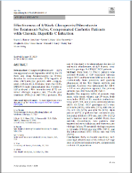  MANUSCRIPT
Real-World Efficacy of Direct Acting Antiviral Therapies in Patients with HIV/HCV  Authors: Sonia Vibhakar Patel, Dushyantha T. Jayaweera‡, Keri N. Althoff, Joseph J. Eron, Janna Radtchenko, Anthony Mills, Graeme Moyle, Steven Santiago, Paul E. Sax, Jason Gillman, Karam Mounzer, Richard A. Elion, and Gregory D. Huhn  DOI: 10.1371/journal.pone.0228847  Published in: PLOS ONE: February 13, 2020 |  |  |  | 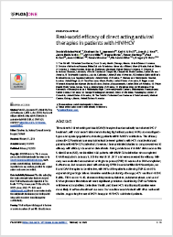  MANUSCRIPT
Real-World Effectiveness and Safety of Glecaprevir/Pibrentasvir for the Treatment of Patients with Chronic HCV Infection: A Meta-Analysis  Authors: Pietro Lampertico, Jose A. Carrion, Michael Curry, Juan Turnes, Markus Cornberg, Francesco Negro, Ashley Brown, Marcello Persico, Nicole Wick, Ariel Porcalla, Andreas Pangerl, Eric Crown, Lois Larsen, Yao Yu, Heiner Wedemeyer  DOI: 10.1016/j.jhep.2020.01.025  Published in: Journal of Hepatology: February 12, 2020 |  |  |  | 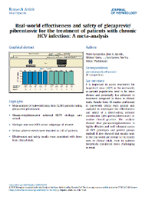  MANUSCRIPT

The American Association for the Study of Liver Diseases (AASLD) 2019
Drug-Drug Interactions (DDIs) with Pangenotypic Direct-Acting Antivirals (DAAs) in Patients with Hepatitis C: Understanding the Populations at Risk and Real-World Care Management  Authors: Dr. Michael P. Curry, Prof. Naoky C Tsai, Dr. Bruce R Bacon, Dr. Steven L Flamm, Prof. Zobair M Younossi, MD, MPH, FAASLD, Dr. Scott Milligan, Mrs. Nicole Wick, and Nezam H Afdhal  Poster presented at: The Liver Meeting. 70th Annual Meeting of the American Association for the Study of Liver Diseases; 2019 Nov 8-12; Boston, MA |  |  |  | 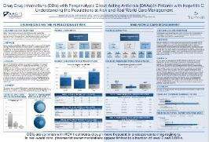  POSTER
Pangenotypic Therapies Glecaprevir-Pibrentasvir (GLE-PIB) and Sofosbuvir-Velpatasvir-Voxilaprevir (SOF-VEL-VOX) After Failure with Interferon (IFN)-Free Direct-Acting Antiviral (DAA) Treatment for Hepatitis C  Authors: Steven L Flamm, Naoky C Tsai, Bruce R Bacon, Michael P. Curry, Scott Milligan, Nicole Wick, Zobair M Younossi, and Nezam H Afdhal  Poster presented at: The Liver Meeting. 70th Annual Meeting of the American Association for the Study of Liver Diseases; 2019 Nov 8-12; Boston, MA |  |  |  | 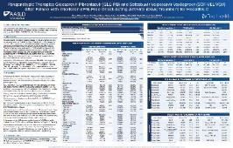  POSTER

The European AIDS Clinical Society (EACS) 2019
Untreated HCV in HIV/HCV-Coinfected US Population Despite an Abundance of Curative Therapies  Authors: R. Elion, K. Althoff, J. Eron, J. Gillman, R. Haubrich, G. Huhn, S. Milligan, A. Mills, K. Mounzer, G. Moyle, J. Radtchenko, S. Santiago, P. Sax, and D. Jayaweera  The 17th European AIDS Clinical Society; 2019 Nov 6-9: PE19  Poster presented at: The 17th European AIDS Conference; 2019 Nov 6-9; Basel, Switzerland |  |  | 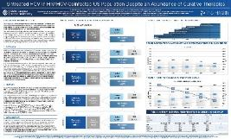  POSTER

American College of Gastroenterology (ACG) 2019
Real-World Effectiveness and Safety of Glecaprevir/Pibrentasvir in Adults with Chronic Hepatitis C Virus Infection: A Meta-Analysis  Authors: Markus Cornberg, Francesco Negro, Pietro Lampertico, Juan Turnes, Michael P. Curry, Ashley Brown, Heiner Wedemeyer, Jose A Carrion, Nicole Wick, Andreas Pangerl, Eric Crown, Lois Larsen, Yao Yu, and Marcello Persico  Poster presented at: American College of Gastroenterology 2019 Conference; 2019 Oct 25-29; San Antonio, Texas |  |  | 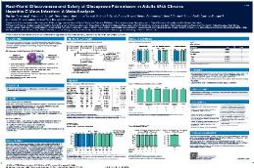  POSTER

Canadian Liver Meeting 2019
Global Real World Evidence of Sofosbuvir/Velpatasvir as a Simple, Effective Regimen for the Treatment of Chronic Hepatitis C: Integrated Analysis of 12 clinical Practice Cohorts  Authors: Dr. Alessandra Mangia, Dr. Scott Milligan, Prof. Mandana Khalili, Prof. Stefano Fagiuoli, Dr. Stephen D. Shafran, Prof. Fabrice Carrat, Prof. Denis Ouzan, Prof. George Papatheodoridis, Dr. Sergio M Borgia, Prof. Heiner Wedemeyer, Valeria Piazzolla, Francisco Perez, Ms. Nicole Wick, Dr. Dawn Fishbein, Prof. Pietro Lampertico, Dr. Karen Doucette, Dr. Michael Mertens, Dr. Kim Vanstaelen, Dr. A. Anna Cumaraswamy, Dr. Juan Turnes  Oral presented at: Canadian Liver Meeting 2019 Conference; 2019 May 24-26; Montreal, Canada |  |  | 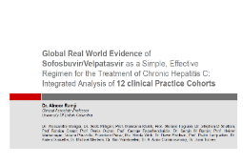  ORAL PRESENTATION

International Society for Pharmacoeconomics and Outcomes Research (ISPOR) 2019
Access to HCV Cure Under Medicaid Programs in the United States  Authors: Zobair Younossi, Bruce Bacon, Michael Curry, Steven L Flamm, Scott Milligan, Janna Radtchenko, Naoky Tsai, and Nezam Afdhal  Poster presented at: ISPOR 2019 Conference; 2019 May 18-22; New Orleans, LA |  |  | 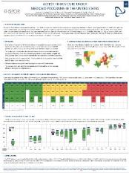  POSTER

The European Association for the Study of the Liver (EASL) 2019
Access to Direct Acting Antiviral Agents in HIV/HCV Co-Infected Population in the US  Authors: Dushyantha Jayaweera, Keri Althoff, Joseph Eron, Gregory Huhn, Janna Radtchenko, Scott Milligan, Anthony Mills, Graeme Moyle, Steven Santiago, Paul Sax, Jason Gillman, Karam Mounzer, and Rick Elion  2019 Apr 10-Online Access  Poster presented at: The International Liver Congress. 54th Annual Meeting of the European Association for the Study of the Liver; 2019 Apr 10-14; Vienna, Austria |  |  | 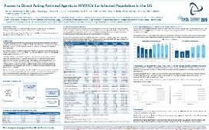  POSTER
Clinical Practice Experience with Pangenotypic Therapies Glecaprevir-Pibrentasvir and Sofosbuvir-Velpatasvir; Data from the Trio Network  Authors: Michael Curry, Bruce Bacon, Steven L Flamm, Nicole Wick, Scott Milligan, Naoky Tsai, Zobair Younossi, and Nezam Afdhal  Poster presented at: The International Liver Congress. 54th Annual Meeting of the European Association for the Study of the Liver; 2019 Apr 10-14; Vienna, Austria |  |  | 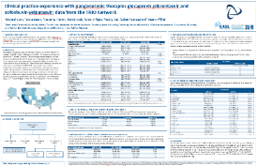  POSTER
Effectiveness of the Salvage Therapy Sofosbuvir/Velpatasvir/Voxilaprevir (SOF/VEL/VOX) in Chronic Hepatitis C; Clinical Practice Experience from the Trio Network  Authors: Bruce Bacon, Michael Curry, Steven L Flamm, Scott Milligan, Naoky Tsai, Nicole Wick, Zobair Younossi, and Nezam Afdhal  Poster presented at: The International Liver Congress. 54th Annual Meeting of the European Association for the Study of the Liver; 2019 Apr 10-14; Vienna, Austria |  |  | 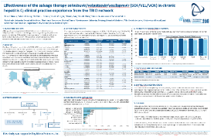  POSTER
Real-World Effectiveness of 8-Week Glecaprevir/Pibrentasvir (G/P) for Treatment Naïve, Noncirrhotic Patients with HIV Infection in the TRIO Network  Authors: Michael P. Curry, Jens Kort, Steven E. Marx, John Strezewski, Nicole Wick, Steven L. Flamm, Bruce Bacon, and Naoky Tsai  Published in: GastroHep Wiley Online Library: November 23, 2019 |  |  | 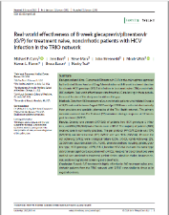  MANUSCRIPT
Changing Demographics Among Populations - Prescribed HCV Treatment, 2013-2017  Authors: Naoky Tsai, MD, Bruce Bacon, MD, Michael Curry, MD, Steven L.  Flamm MD, Scott Milligan, PhD, Nicole Wick, AS, Zobair Younossi, MD, and Nezam Afdhal, MD  American Journal of Managed Care  Published in: American Journal of Managed Care (AJMC): July 12, 2019 |  |  | 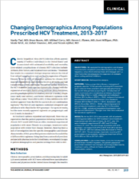  MANUSCRIPT

The American Association for the Study of Liver Diseases (AASLD) 2018
Change in Demographics of Direct-Acting Antiviral (DAA)-Prescribed HCV Patients from 2013 to 2018: Data from 19,994 Patients in the TRIO Network  Authors: Naoky Tsai, Bruce Bacon, Michael Curry, Steven L. Flamm, Scott Milligan, Nicole Wick, Zobair Younossi and Nezam Afdhal.  Poster presented at: The Liver Meeting. 69th Annual Meeting of the American Association for the Study of Liver Diseases; 2018 Nov 9-13; Washington, DC |  |  | 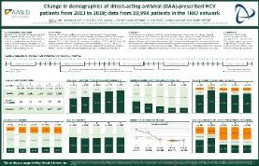  POSTER
Effectiveness of 8-week Glecaprevir/Pibrentasvir (G/P) for Treatment Naïve, Non-Cirrhotic Patients with HCV Infection in the TRIO Health Network  Authors: Steven L. Flamm, Jens Kort, Steve Marx, John Strezewski, Bruce  Bacon, Michael P. Curry, Naoky Tsai, Nicole Wick, Zobair Younossi; and Nezam Afdhal  Poster presented at: The Liver Meeting. 69th Annual Meeting of the American Association for the Study of Liver Diseases; 2018 Nov 9-13; Washington, DC |  |  | 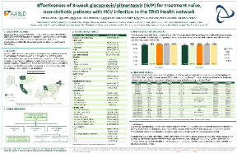  POSTER
Preferences and Outcomes in Clinical Practice with Glecaprevir/Pibrentasvir (GLE-PIB), Ledipasvir/Sofosbuvir (LDV-SOF), and Sofosbuvir/Velpatasvir (SOFVEL): Data from the TRIO Network  Authors: Michael Curry, Bruce Bacon, Steven L. Flamm, Michael Marks, Scott Milligan, Naoky Tsai, Zobair Younossi, and Nezam Afdhal  Poster presented at: The Liver Meeting. 69th Annual Meeting of the American Association for the Study of Liver Diseases; 2018 Nov 9-13; Washington, DC |  |  | 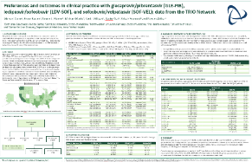  POSTER
Sofosbuvir/Velpatasvir/Voxilaprevir (SOF/VEL/VOX) in Care of Chronic Hepatitis C Patients: Clinical Practice Experience from the TRIO Network  Authors: Bruce Bacon, Michael Curry, Steven L. Flamm, Scott Milligan, Naoky Tsai, Nicole Wick, Zobair Younossi, and Nezam Afdhal  Poster presented at: The Liver Meeting. 69th Annual Meeting of the American Association for the Study of Liver Diseases; 2018 Nov 9-13; Washington, DC |  |  | 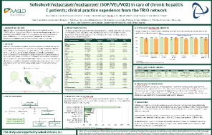  POSTER
Disparities in Accessing HCV Care Under Medicaid Programs Across the US: Experience from the TRIO Network  Authors: Zobair Younossi, Bruce Bacon, Michael Curry, Steven L. Flamm, Scott Milligan, Nicole Wick, Naoky Tsai, and Nezam Afdhal  Oral presentation at: The Liver Meeting. 69th Annual Meeting of the American Association for the Study of Liver Diseases; 2018 Nov 9-13; Washington, DC |  |  | 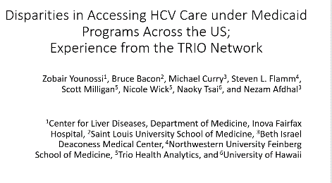  ORAL PRESENTATION

Global Hepatitis Summit (GHS) 2018
Realized Durations of Direct-Acting Antivirals (DAAs) in Care of HCV in US Clinical Practice: Data from the Trio Network  Authors: Michael Curry, Bruce Bacon, Steven Flamm, Scott Milligan, Naoky Tsai, Zobair Younossi, and Nezam Afdhal.  Poster presented at: Global Hepatitis Summit. 2018 June 14-17; Toronto, Canada |  |  | 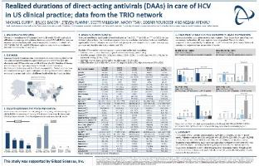  POSTER

Digestive Disease Week (DDW) 2018
Effectiveness of 8 vs. 12 Week Ledipasvir/Sofosbuvir (LDV/SOF) in Black, Treatment Naïve Patients with Non-Cirrhotic, Genotype 1 HCV and Baseline Viral Load <6mm IU/ml: Analyses of Real-World Data from the TRIO Network  Authors: Michael Curry, Bruce Bacon, Steven Flamm, Angela Landen, Scott Milligan, Naoky Tsai, Zobair Younossi, and Nezam Afdhal  Poster presented at: Digestive Disease Week. 2018 June 2-5; Washington, DC |  |  | 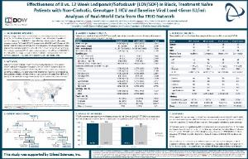  POSTER
Access to and Utilization of Sofosbuvir/Velpatasvir/Voxilaprevir in Care of Chronic Hepatitis C Patients: Data from the TRIO Network  Authors: Bruce Bacon, Michael Curry, Steven Flamm, John Straub, Naoky  Tsai, Nicole Wick, Zobair Younossi, and Nezam Afdhal  Poster presented at: Digestive Disease Week. 2018 June 2-5; Washington DC |  |  | 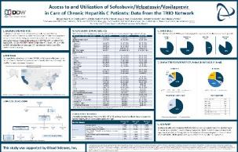  POSTER
Untreated HCV in HIV/HCV Co-Infection: Data from the TRIO Network  Authors: Dushwantha Jayaweera, Joseph Eron, Gregory Huhn, Scott  Milligan, Anthony Mills, Graeme Moyle, Steven Santiago, Paul Sax, Gene  Voskuhl, David Wyles, Karam Mounzer, and Rick Elion  DOI: 10.1016/S0016-5085(18)33931-3  Poster presented at: Digestive Disease Week. 2018 June 2-5; Washington DC |  |  | 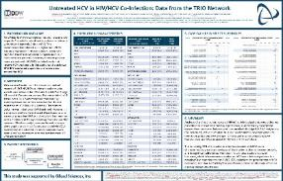  POSTER
Utilization and Outcomes of Elbasvir/Grazoprevir in Genotype 1B Chronic Hepatitis C: Updated Retrospective Data Analyses from the TRIO Network  Authors: Naoky Tsai, Bruce Bacon, Michael Curry, Steven Flamm, Scott Milligan, Chizoba Nwankwo, Nicole Wick, Zobair Younossi, and Nezam Afhdal  Poster presented at: Digestive Disease Week. 2018 June 2-5; Washington DC |  |  | 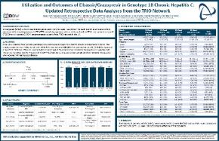  POSTER
Effectiveness of Elbasvir/Grazoprevir in Patients with Cirrhotic Genotype 1 or 4 Chronic Hepatitis C: Updated Retrospective Data Analyses from the TRIO Network  Authors: Michael Curry, Steven Flamm, Bruce Bacon, Scott Milligan, Chizoba Nwankwo, Naoky Tsai, Nicole Wick, Zobair Younossi, and Nezam Afdhal.  Poster presented at: Digestive Disease Week. 2018 June 2-5; Washington DC |  |  | 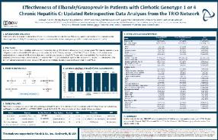  POSTER
Impact of HCV Viral Load on Elbasvir/Grazoprevir Effectiveness in Chronic Hepatitis C: Updated Retrospective Data Analyses from the TRIO Network  Authors: Steven Flamm, Bruce Bacon, Michael Curry, Scott Milligan, Chizoba Nwankwo, Naoky Tsai, Nicole Wick, Zobair Younossi and Nezam Afdhal.  Poster presented at: Digestive Disease Week. 2018 June 2-5; Washington DC |  |  | 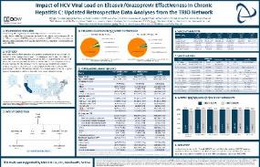  POSTER
Behavioral and Clinical Factors and Direct Acting Antiviral (DAA) Effectiveness in HCV/HIV Co-Infection: Clinical Experience from the TRIO Network  Authors: Rick Elion, Gregory Huhn, Dushyantha Jayaweera, Keri Althoff,  Joseph Eron, Scott Milligan, Anthony Mills, Graeme Moyle, Steven Santiago, Paul Sax, Gene Voskuhl, David Wyles, and Karam Mounzer  DOI: 10.1016/S0016-5085(18)33670-9  Oral presented at: Digestive Disease Week. 2018 June 2-5; Washington DC |  |  | 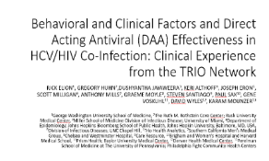  ORAL PRESENTATION

The European Association for the Study of the Liver (EASL) 2018
Effectiveness of 8 vs. 12 Week Ledipasvir/Sofosbuvir (LDV/SOF) in Black, Treatment Naïve Patients with Non-Cirrhotic, Genotype 1 HCV and Baseline Viral Load: Analyses of Real-World Data from the TRIO Network  Authors: Michael Curry, Bruce Bacon, Steven Flamm, Angela Landen, Scott Milligan, Naoky Tsai, Zobair Younossi, and Nezam Afdhal  Poster presented at: The International Liver Congress. 53rd Annual Meeting of the European Association for the Study of the Liver; 2018 Apr 11-15; Paris, France |  |  | 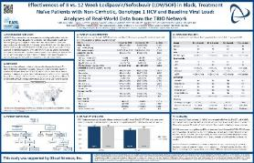  POSTER
Behavioral and Clinical Factors and Direct Acting Antiviral Effectiveness in HCV/HIV Co-Infection: Clinical Experience from the TRIO Network  Authors: Gregory Huhn, Dushyantha Jayaweera, Keri Althoff, Joseph Eron,  Scott Milligan, Anthony Mills, Graeme Moyle, Steven Santiago, Paul Sax,  Gene Voskuhl, David Wyles, Karam Mounzer, and Rick Elion  DOI: 10.1016/S0168-8278(18)30723-2  Poster presented at: The International Liver Congress. 53rd Annual Meeting of the European Association for the Study of the Liver; 2018 Apr 11-15; Paris, France |  |  | 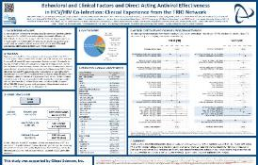  POSTER
Utilization and Outcomes of Elbasvir/Grazoprevir in Genotype 1B Chronic Hepatitis C: Updated Retrospective Data Analyses from the TRIO Network  Authors: Naoky Tsai, Bruce Bacon, Michael Curry, Steven Flamm, Scott  Milligan, Chizoba Nwankwo, Nicole Wick, Zobair Younossi, and Nezam Afdhal  Poster presented at: The International Liver Congress. 53rd Annual Meeting of the European Association for the Study of the Liver; 2018 Apr 11-15; Paris, France |  |  | 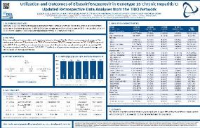  POSTER
Effectiveness of Elbasvir/Grazoprevir in Patients with Cirrhotic Genotype 1 or 4 Chronic Hepatitis C: Updated Retrospective Data Analyses from the TRIO Network  Authors: Michael Curry, Steven Flamm, Bruce Bacon, Scott Milligan, Chizoba Nwankwo, Naoky Tsai, Nicole Wick, Zobair Younossi, and Nezam Afdhal  Poster presented at: The International Liver Congress. 53rd Annual Meeting of the European Association for the Study of the Liver; 2018 Apr 11-15; Paris, France |  |  | 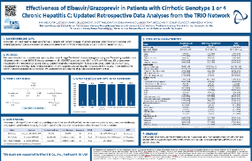  POSTER
Impact of HCV Viral Load on Elbasvir/Grazoprevir Effectiveness in Chronic Hepatitis C: Updated Retrospective Data Analyses from the TRIO Network  Authors: Steven Flamm, Bruce Bacon, Michael Curry, Scott Milligan, Chizoba Nwankwo, Naoky Tsai, Nicole Wick, Zobair Younossi, and Nezam Afdhal  Poster presented at: The International Liver Congress. 53rd Annual Meeting of the European Association for the Study of the Liver; 2018 Apr 11-15; Paris, France |  |  | 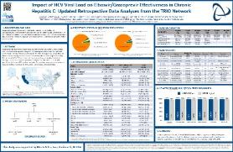  POSTER
The Impact of Individual Patient Data in a Network Meta Analysis: An Investigation Into Parameter Estimation and Model Selection  Authors: Joy Leahy, Aisling O’Leary, Nezam Afdhal, Emma Gray, Scott Milligan, Malte H. Wehmeyer, and Cathal Walsh  Published in: Research Synthesis Methods: June 20, 2018 |  |  | 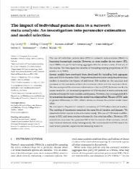  MANUSCRIPT
Real‐world Use of Elbasvir‐Grazoprevir in Patients with Chronic Hepatitis C: Retrospective Analyses from the TRIO Network  Authors: Flamm, SL, Bacon B, Cury MP, Milligan S, Nwankwo CU, Tsai N, Younossi Z, and Afdhal N  Published in: Alimentary Pharmacology & Therapeutics (AP&T): April 17, 2018 |  |  | 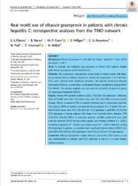  MANUSCRIPT

The American Association for the Study of Liver Diseases (AASLD)
Real-World Patterns of Therapy Utilization and Outcomes in 8,049 HCV Patients: Data from the TRIO Network  Authors: Steven L. Flamm, Bruce Bacon, Michael Curry, Douglas T. Dieterich, Kris Kowdley, Scott Milligan, Naoky Tsai, Zobair Younossi, and Nezam Afdhal  Poster presented at: The Liver Meeting. 68th Annual Meeting of the American Association for the Study of Liver Diseases; 2017 Oct 20-24; Washington, DC |  |  | 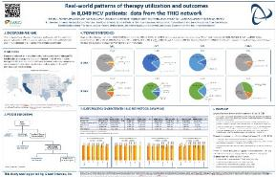  POSTER
Drivers of Therapy Choice in Genotype 1 HCV: Analyses of Real-World Data from the TRIO Network  Authors: M. Curry, B. Bacon, D. Dieterich, S.L. Flamm, K. Kowdley, S. Milligan, N. Tsai, Z. Younossi. and N. Afdhal  Poster presented at: The Liver Meeting. 68th Annual Meeting of the American Association for the Study of Liver Diseases; 2017 Oct 20-24; Washington, DC |  |  | 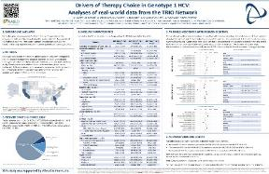  POSTER
HCV Treatment Failure in the Era of Direct-Acting Antivirals (DAAs): Analyses of Real-World Data from the TRIO Network  Authors: Bruce Bacon, Steven L. Flamm, Michael Curry, Douglas T. Dieterich, Kris Kowdley, Scott Milligan, Naoky Tsai, Zobair Younossi, and Nezam Afdhal  Poster presented at: The Liver Meeting. 68th Annual Meeting of the American Association for the Study of Liver Diseases; 2017 Oct 20-24; Washington, DC |  |  | 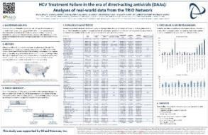  POSTER
Cure Denied and Cure Delayed in Chronic Hepatitis C; Monitoring Non-Start Rates and Increased Time to Start Using Real-World Data from the TRIO Network  Authors: Zobair Younossi, Bruce Bacon, Michael Curry, Douglas T. Dieterich, Steven L. Flamm, Kris Kowdley, Scott Milligan, Naoky Tsai, and Nezam Afdhal  Poster presented at: The Liver Meeting. 68th Annual Meeting of the American Association for the Study of Liver Diseases; 2017 Oct 20-24; Washington, DC |  |  | 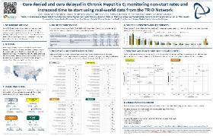  POSTER
Impact of Treatment Duration and Ribavirin (RBV) Addition on Real-World Effectiveness of Elbasvir/Grazoprevir (EBR-GZR) in Select Patient Subgroups with Genotype 1 (GT1) Chronic Hepatitis C (HCV): Retrospective Data Analyses from the TRIO Network  Authors: C. Nwankwo, B. Bacon, M. Curry, D. Dieterich, S.L. Flamm, K. Kowdley, S. Milligan, N. Tsai, Z. Younossi, and N. Afdhal  Poster presented at: The Liver Meeting. 68th Annual Meeting of the American Association for the Study of Liver Diseases; 2017 Oct 20-24; Washington, DC |  |  | 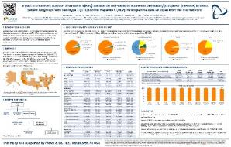  POSTER
Utilization and Effectiveness of Elbasvir/Grazoprevir (EBR-GZR) in Treatment Naïve (TN) Genotype 1a (GT1A) Chronic Hepatitis C Virus (HCV) Patients with/without Baseline NS5A Resistance-Associated Substitutions (RASs)  Authors: C. Nwankwo, B. Bacon, M. Curry, D. Dieterich, S.L. Flamm, K. Kowdley, S. Milligan, N. Tsai, Z. Younossi, and N. Afdhal.  Poster presented at: The Liver Meeting. 68th Annual Meeting of the American Association for the Study of Liver Diseases; 2017 Oct 20-24; Washington, DC |  |  | 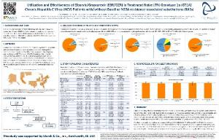  POSTER

Digestive Disease Week (DDW) 2017
Real-World Results in the Renaissance of HCV Care: Analyses of Treatment for 8,955 Patients from the TRIO Network  Authors: S.L. Flamm, B. Bacon, M. Curry, D. Dieterich, K. Kowdley, S. Milligan, N. Tsai, Z. Younossi, and N. Afdhal  Poster presented at: Digestive Disease Week. 2017 May 6-9; Chicago, IL |  |  | 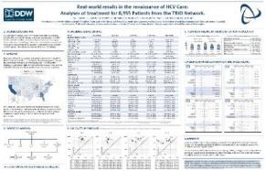  POSTER
Sofosbuvir/ Velpatasvir Compared to Existing Standards of Care in GT2-6 HCV  Authors: Michael Curry, Bruce Bacon, Douglas Dieterich, Steven L. Flamm, Kris Kowdley, Scott Milligan, Naoky Tsai, Zobair Younossi, and Nezam Afdhal  Oral presented at: Digestive Disease Week. 2017 May 6-9; Chicago, IL |  |  | 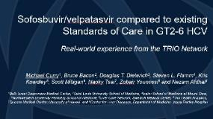  ORAL PRESENTATION
Utilization of DAA Therapies Ledipasvir/Sofosbuvir and Sofosbuvir/Velpatasvir in Patients with Genotype 1 HCV: Real-World Experience from the TRIO Network  Authors: N. Tsai, B. Bacon, M. Curry, D. Dieterich, S.L. Flamm, K. Kowdley, S. Milligan, Z. Younossi, and N. Afdhal  Poster presented at: Digestive Disease Week. 2017 May 6-9; Chicago, IL |  |  | 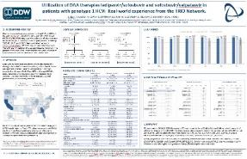  POSTER
Access to HCV Care for 31,154 Patients in the United States Real-World Experience from the TRIO Network  Authors: Zobair Younossi, Bruce Bacon, Michael Curry, Douglas T. Dieterich, Steven L. Flamm, Kris Kowdley, Scott Milligan, Naoky Tsai, and Nezam Afdhal  Poster presented at: Digestive Disease Week. 2017 May 6-9; Chicago, IL |  |  | 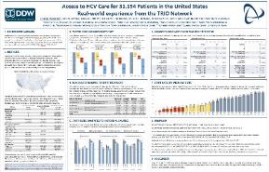  POSTER

The European Association for the Study of the Liver (EASL) 2017
Sofosbuvir/ Velpatasvir Compared to Existing Standards of Care in GT2-6 HCV  Authors: Michael Curry, Bruce Bacon, Douglas Dieterich, Steven L. Flamm, Kris Kowdley, Scott Milligan, Naoky Tsai, Zobair Younossi, and Nezam Afdhal  Oral presented at: The International Liver Congress. 52nd Annual Meeting of the European Association for the Study of the Liver; 2017 Apr 13-17; Amsterdam, Netherlands |  |  | 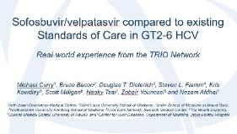  ORAL PRESENTATION
Real-World Treatment Utilization and Results in the Renaissance of HCV Care: Analyses of Treatment for 8,955 Patients from the TRIO Network  Authors: S.L. Flamm, B. Bacon, M. Curry, D. Dieterich, K. Kowdley, S. Milligan, N. Tsai, Z. Younossi, and N. Afdhal  Poster presented at: The International Liver Congress. 52nd Annual Meeting of the European Association for the Study of the Liver; 2017 Apr 13-17; Amsterdam, Netherlands |  |  | 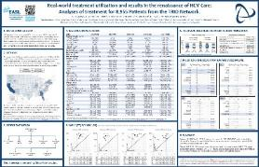  POSTER
Utilization of DAA Therapies Ledipasvir/Sofosbuvir and Sofosbuvir/Velpatasvir in Patients with Genotype 1 HCV: Real-World Experience from the TRIO Network  Authors: N. Tsai, B. Bacon, M. Curry, D. Dieterich, S.L. Flamm, K. Kowdley, S. Milligan, Z. Younossi, and N. Afdhal  Poster presented at: The International Liver Congress. 52nd Annual Meeting of the European Association for the Study of the Liver; 2017 Apr 13-17; Amsterdam, Netherlands |  |  | 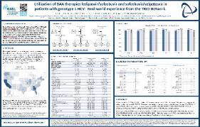  POSTER
Elbasvir/Grazoprevir Effectiveness in Patients with Chronic Hepatitis C and Chronic Kidney Disease: Real-World Experience from the TRIO Network  Authors: Z. Younossi, B. Bacon, M. Curry, D. Dieterich, S.L. Flamm, K. Kowdley, S. Milligan, C. Nwankwo, and N. Afdhal  Poster presented at: The International Liver Congress. 52nd Annual Meeting of the European Association for the Study of the Liver; 2017 Apr 13-17; Amsterdam, Netherlands |  |  | 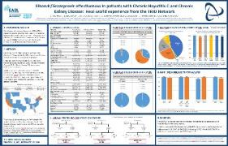  POSTER
Real-World Use of Elbasvir/Grazoprevir and Outcomes in Patients with Chronic Hepatitis C: Retrospective Data Analyses from the TRIO Network  Authors: B. Bacon, M. Curry, D. Dieterich, S.L. Flamm, K. Kowdley, S. Milligan, C. Nwankwo, N. Tsai, Z. Younossi, and N. Afdhal  Poster presented at: The International Liver Congress. 52nd Annual Meeting of the European Association for the Study of the Liver; 2017 Apr 13-17; Amsterdam, Netherlands |  |  | 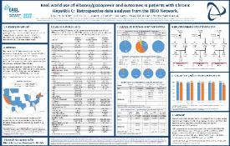  POSTER

The American Association for the Study of Liver Diseases (AASLD) 2016
Effect of Ethnicity on HCV Patient Outcomes and Access to Therapy in Era of All DAA Regimens: Real-World Experience from the TRIO Network  Authors: Kevin Korenblat, Bruce Bacon, Michael Curry, Douglas Dieterich, Steven L. Flamm, Kris V. Kowdley, Yoori Lee, Naoky Tsai, Zobair Younossi, and Nezam Afdhal  Poster presented at: The Liver Meeting. 67th Annual Meeting of the American Association for the Study of Liver Diseases; 2016 Nov 11-15; Boston, MA |  |  | 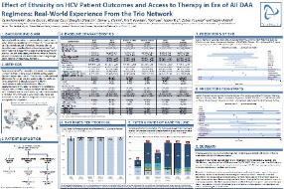  POSTER

International Society for Pharmacoeconomics and Outcomes Research (ISPOR) 2016
Effectiveness of 8 or 12 week LDV/SOF in Treatment-Naïve Patients with NonCirrhotic, Genotype 1 Hepatitis C: Real-World Experience from the TRIO Network  Authors: Michael P. Curry, Bruce Bacon, Douglas Dieterich, Steven L. Flamm, Lauren Guest, Kris V. Kowdley, Yoori Lee, Naoky Tsai, and Zobair Younossi  Poster presented at: ISPOR 2016. 21st Annual Meeting of the International Society for Pharmacoeconomics and Outcomes Research; 2016 May 21-25; Washington DC |  |  | 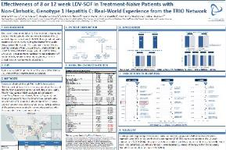  POSTER
Effectiveness of 12 or 24 week LDV-SOF and 12 week LDV-SOF + RBV in Treatment-Experienced Patients with Cirrhotic, Genotype 1 Hepatitis C: Real-World Experience from the TRIO Network  Authors: Michael P. Curry, Bruce Bacon, Douglas Dieterich, Steven L. Flamm, Lauren Guest, Kris V. Kowdley, Yoori Lee, Naoky Tsai, and Zobair Younossi  Poster presented at: ISPOR 2016. 21st Annual Meeting of the International Society for Pharmacoeconomics and Outcomes Research; 2016 May 21-25; Washington DC |  |  | 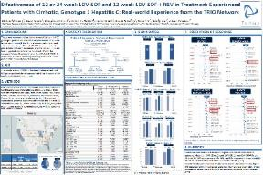  POSTER

Digestive Disease Week (DDW) 2016
Ledipasvir/Sofosbuvir+/-Ribavirin in Patients Co-Infected with HCV and HIV: Real-World Heterogeneous Population from the TRIO Network  Authors: Douglas T. Dieterich, Bruce Bacon, Michael Curry, Steven L. Flamm, Lauren Guest, Kris Kowdley, Yoori Lee, Zobair Younossi, Naoky Tsai, and Nezam Afdhal  Poster presented at: Digestive Disease Week. 2016 May 21-24; San Diego, CA |  |  | 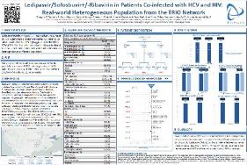  POSTER
Access to Therapy in Era of DAA Regimens: Real-World Experience from the TRIO Network  Authors: Douglas T. Dieterich, Bruce Bacon, Michael Curry, Steven L. Flamm, Kris Kowdley, Yoori Lee, Zobair Younossi, Naoky Tsai, and Nezam Afdhal  Poster presented at: Digestive Disease Week. 2016 May 21-24; San Diego, CA |  |  | 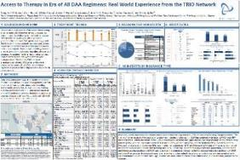  POSTER
Failure with All-oral DAA Regimens: Real-World Experience from the Trio Network  Authors: Nezam Afdhal, Bruce Bacon, Michael Curry, Douglas Dieterich, Steven L. Flamm, Lauren Guest, Kris V. Kowdley, Yoori Lee, Naoky Tsai, and Zobair Younossi  Poster presented at: Digestive Disease Week. 2016 May 21-24; San Diego, CA |  |  | 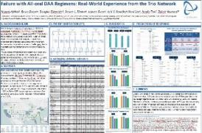  POSTER

International Liver Transplantation Society (ILTS) 2016
Ledipasvir/Sofosbuvir +/- Ribavirin in HCV Post-Transplant Patients: Real-World Heterogeneous Population from the TRIO Network  Authors: Steven L. Flamm, Bruce Bacon, Michael Curry, Douglas T. Dieterich, Lauren Guest, Kris Kowdley, Yoori Lee, Naoky Tsai, Zobair Younossi, and Nezam Afdhal  Poster presented at: ILTS 2016. 22nd Annual Congress of the International Liver Transplantation Society; 2016 May 4-7; Seoul, South Korea |  |  | 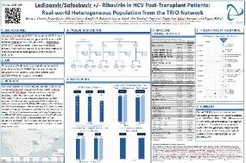  POSTER

The European Association for the Study of the Liver (EASL) 2016
Ledipasvir/Sofosbuvir+/-Ribavirin in Patients Co-Infected with HCV and HIV: Real-World Heterogeneous Population from the TRIO Network  Authors: Douglas T. Dieterich, Bruce Bacon, Michael Curry, Steven L. Flamm, Lauren Guest, Kris Kowdley, Yoori Lee, Zobair Younossi, Naoky Tsai, and Nezam Afdhal  Poster presented at: The International Liver Congress. 51st Annual Meeting of the European Association for the Study of the Liver; 2016 Apr 13-17; Barcelona, Spain |  |  | 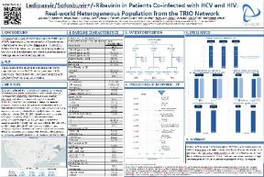  POSTER
Ledipasvir/Sofosbuvir +/- Ribavirin in HCV Post-Transplant Patients: Real-World Heterogeneous Population from the TRIO Network  Authors: Steven L. Flamm, Bruce Bacon, Michael Curry, Douglas T. Dieterich, Lauren Guest, Kris Kowdley, Yoori Lee, Naoky Tsai, Zobair Younossi, and Nezam Afdhal  Poster presented at: The International Liver Congress. 51st Annual Meeting of the European Association for the Study of the Liver; 2016 Apr 13-17; Barcelona, Spain |  |  | 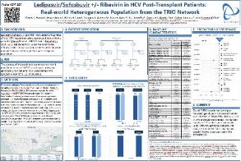  POSTER
No Effect of Proton Pump Inhibitor (PPI) Use on SVR with Ledipasvir/ Sofosbuvir (LDV/SOF): Real-World Data from 2,034 Genotype 1 Patients in the TRIO Network  Authors: Nezam Afdhal, Bruce Bacon, Michael Curry, Douglas Dieterich, Steven L. Flamm, Lauren Guest, Kris V. Kowdley, Yoori Lee, Naoky Tsai, and Zobair Younossi  Poster presented at: The International Liver Congress. 51st Annual Meeting of the European Association for the Study of the Liver; 2016 Apr 13-17; Barcelona, Spain |  |  | 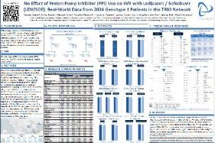  POSTER

Asian Pacific Association for the Study of the Liver (APASL) 2016
Evaluation of Efficacy of Ledipasvir/Sofosbuvir for 12 weeks in a Real-Life Population of Genotype 1a and 1b HCV Patients: Data from the TRIO Network  Authors: Nezam Afdhal, Bruce Bacon, Michael Curry, Douglas Dieterich, Steven L. Flamm, Lauren Guest, Kris V. Kowdley, Yoori Lee, Naoky Tsai, and Zobair Younossi  Poster presented at: APASL 2016. 25th Annual Conference of the Asian Pacific Association for the Study of Liver (APASL); 2016 Feb 20-24; Tokyo, Japan |  |  | 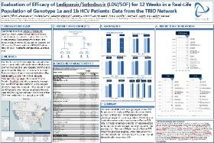  POSTER
Real-world Effectiveness for 12 Weeks of Ledipasvir-Sofosbuvir for Genotype 1 Hepatitis C: The TRIO Health Study  Authors: E. B. Tapper, B. R. Bacon, M. P. Curry, D. T. Dieterich, S. L. Flamm, L. E. Guest, K. V. Kowdley, Y. Lee, N. C. Tsai, Z. M. Younossi, and N. H. Afdhal  Published in: Journal of Viral Hepatitis: October 11, 2016 |  |  | 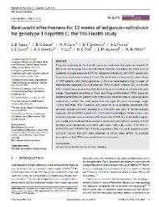  MANUSCRIPT
Evaluation of Proton Pump Inhibitor Use on Treatment Outcomes with Ledipasvir and Sofosbuvir in a Real-World Cohort Study  Authors: Elliot B. Tapper, Bruce R. Bacon, Michael P. Curry, Douglas T. Dieterich, Steven L. Flamm, Lauren E. Guest, Kris V. Kowdley, Yoori Lee, Naoky C. Tsai, Zobair M. Younossi, and Nezam H. Afdhal  Published in: Hepatology: August 17, 2016 |  |  | 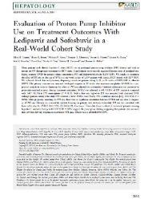  MANUSCRIPT
Disparate Access to Treatment Regimens in Chronic Hepatitis C Patients: Data from the TRIO Network  Authors: Z. M. Younossi, B. R. Bacon, D. T. Dieterich, S. L. Flamm, K. Kowdley, S. Milligan, N. Tsai, and A. Nezam  Published in: Journal of Viral Hepatitis: February 3, 2016 |  |  | 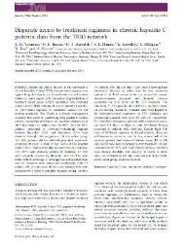  MANUSCRIPT

The American Association for the Study of Liver Diseases (AASLD) 2015
Effectiveness of 8 or 12-week LDV-SOF in Treatment-Naïve Patients with NonCirrhotic, Genotype 1 Hepatitis C: Real-World Experience from the TRIO Network  Authors: Michael P. Curry, Bruce Bacon, Douglas Dieterich, Steven L. Flamm, Lauren Guest, Kris V. Kowdley, Yoori Lee, Naoky Tsai, and Zobair Younossi  Poster presented at: The Liver Meeting. 66th Annual Meeting of the American Association for the Study of Liver Diseases; 2015 Nov 13-17; San Francisco, CA |  |  | 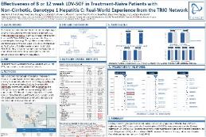  POSTER
Effectiveness of 12 or 24 week LDV-SOF and 12 week LDV-SOF + RBV in Treatment-Experienced Patients with Cirrhotic, Genotype 1 Hepatitis C: Real-World Experience from the TRIO Network  Authors: Michael P. Curry, Bruce Bacon, Douglas Dieterich, Steven L. Flamm, Lauren Guest, Kris V. Kowdley, Yoori Lee, Naoky Tsai, and Zobair Younossi  Poster presented at: The Liver Meeting. 66th Annual Meeting of the American Association for the Study of Liver Diseases; 2015 Nov 13-17; San Francisco, CA |  |  | 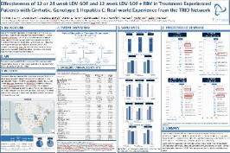  POSTER
Failure with All-Oral DAA Regimens: Academic and Community Treatment of a Real-World Population from the TRIO Network  Authors: Naoky Tsai, Bruce Bacon, Michael Curry, Douglas Dieterich, Steven L. Flamm, Lauren Guest, Kris V. Kowdley, Yoori Lee, Zobair Younossi, and Nezam Afdhal  Poster presented at: The Liver Meeting. 66th Annual Meeting of the American Association for the Study of Liver Diseases; 2015 Nov 13-17; San Francisco, CA |  |  | 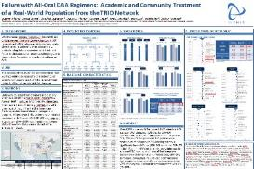  POSTER

Digestive Disease Week (DDW) 2015
Efficacy Evaluation of 24-week SOF + RBV in a Heterogeneous, Real-World Population of Genotype 3 HCV; Data from the TRIO Network  Authors: Kris Kowdley, Bruce Bacon, Douglas T. Dieterich, Eric Lawitz, Scott Milligan, Naoky Tsai, Zobair Younossi, and Steven L. Flamm  Poster presented at: Digestive Disease Week. 2015 May 16-19; Washington DC |  |  | 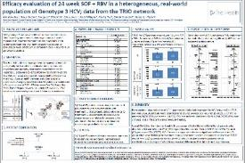  POSTER
Evaluation of Access to Care in Patients Prescribed Sofosbuvir-containing Regimens; Data from the TRIO Network  Authors: Zobair Younossi, Bruce Bacon, Douglas Dieterich, Steven Flamm, Kris Kowdley, Eric Lawitz, Scott Milligan, and Naoky Tsai  Poster presented at: Digestive Disease Week. 2015 May 16-19; Washington DC |  |  | 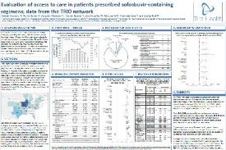  POSTER
Final Evaluation of HCV Patients Treated with 12-week Regimens Containing Sofosbuvir +/- Simeprevir in the TRIO Network: Academic and Community Treatment of a Real-World, Heterogeneous Population  Authors: Douglas Dieterich, Bruce Bacon, Steven Flamm, Kris Kowdley, Scott Milligan, Naoky Tsai, Zobair Younossi, and Eric Lawitz  Poster presented at: Digestive Disease Week. 2015 May 16-19; Washington DC |  |  | 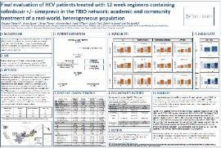  POSTER
Comparison of Sofosbuvir +/- Simeprevir in Heterogeneous, Real-World Populations of HCV Patients over 70 years; Data from the TRIO Network  Authors: Naoky Tsai, Bruce Bacon, Steven L. Flamm, Kris Kowdley, Eric Lawitz, Scott Milligan, Zobair Younossi, Douglas T. Dieterich  Poster presented at: Digestive Disease Week. 2015 May 16-19; Washington, DC |  |  | 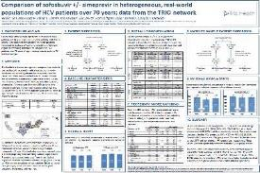  POSTER

The European Association for the Study of the Liver (EASL) 2015
Final Evaluation of HCV Patients Treated with 12-week Regimens Containing Sofosbuvir +/- Simeprevir in the TRIO Network: Academic and Community Treatment of a Real-World, Heterogeneous Population  Authors: Douglas Dieterich, Bruce Bacon, Steven Flamm, Kris Kowdley, Scott Milligan, Naoky Tsai, Zobair Younossi, and Eric Lawitz  Poster presented at: The International Liver Congress. 50th Annual Meeting of the European Association for the Study of the Liver; 2015 Apr 22-26; Vienna, Austria |  |  | 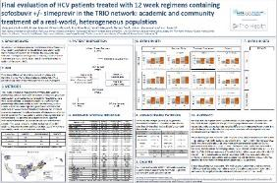  POSTER
Comparison of Sofosbuvir +/- Simeprevir in Heterogeneous, Real-World Populations of HCV Patients over 70 years; Data from the TRIO Network  Authors: Naoky Tsai, Bruce Bacon, Steven L. Flamm, Kris Kowdley, Eric Lawitz, Scott Milligan, Zobair Younossi, and Douglas T. Dieterich  Poster presented at: The International Liver Congress. 50th Annual Meeting of the European Association for the Study of the Liver; 2015 Apr 22-26; Vienna, Austria |  |  | 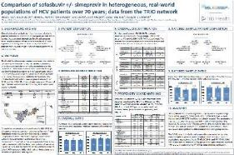  POSTER
Efficacy Evaluation of 24-week SOF + RBV in a Heterogeneous, Real-World Population of Genotype 3 HCV; Data from the TRIO Network  Authors: Kris Kowdley, Bruce Bacon, Douglas T. Dieterich, Eric Lawitz, Scott Milligan, Naoky Tsai, Zobair Younossi, and Steven L. Flamm  Poster presented at: The International Liver Congress. 50th Annual Meeting of the European Association for the Study of the Liver; 2015 Apr 22-26; Vienna, Austria |  |  | 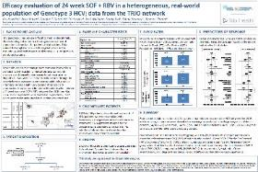  POSTER

The American Association for the Study of Liver Diseases (AASLD) 2014
Evaluation of Sofosbuvir and OLYSIO-based Regimens in the TRIO Network: Academic and Community Treatment of a Real-World, Heterogeneous Population  Authors: D Dieterich, B Bacon, S Flamm, K Kowdley, S Milligan, N Tsai, Z Younossi, E Lawitz  Oral presented at: The Liver Meeting. 65th Annual Meeting of the American Association for the Study of Liver Diseases; 2014 Nov 7-11; Boston, MA |  |  | 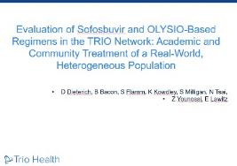  ORAL PRESENTATION
Efficacy of Sofosbuvir and Simeprevir-Based Regimens for HCV Treatment- Experienced GT1 Patients in a Real-Life Setting; Data from the TRIO Network  Authors: Bruce Bacon, Douglas Dieterich, Steven Flamm, Kris Kowdley, Eric Lawitz, Scott Milligan, Zobair Younossi, and Naoky Tsai  Poster presented at: The Liver Meeting. 65th Annual Meeting of the American Association for the Study of Liver Diseases; 2014 Nov 7-11; Boston, MA |  |  | 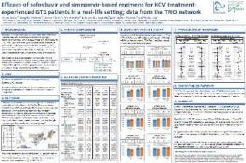  POSTER
Evaluation of Efficacy of Sofosbuvir and Simeprevir-based Regimens in a Real-Life Population of HCV Patients with Cirrhosis; Data from the TRIO Network  Authors: Steven Flamm, Bruce Bacon, Douglas Dieterich, Kris Kowdley, Eric Lawitz, Scott Milligan, Naoky Tsai, and Zobair Younossi  Poster presented at: The Liver Meeting. 65th Annual Meeting of the American Association for the Study of Liver Diseases; 2014 Nov 7-11; Boston, MA |  |  | 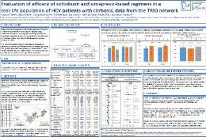  POSTER

HIV

25th International AIDS Conference 2024
Characteristics and Outcomes of Virally Suppressed (VS) Treatment Experienced (VSTE) People with HIV (PWH)  Authors: Gregory Huhn, Joshua Gruber, Isobel McEwen, Megan Dunbar, Janna Radtchenko, Charles Walworth, Joseph J. Eron, Karam Mounzer, Sebastian Ruhs, Moti Ramgopal, Steven Santiago, Richard A. Elion  Poster presentated at: International AIDS Conference; 2024 July, 22-26; Munich, Germany  Online access | 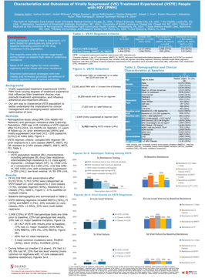  POSTER
Outcomes in People with HIV (PWH) Who Resume or Switch to B/F/TAF Following an Antiretroviral Treatment Interruption (ATI)  Authors: Richard A. Elion, Joshua Gruber, Andrew Frick, Megan Dunbar, Janna Radtchenko, Paul E. Sax, Joseph J. Eron, Gregory Huhn, Anthony Mills, Paul Benson  Poster presentated at: International AIDS Conference; 2024 July, 22-26; Munich, Germany  Online access | 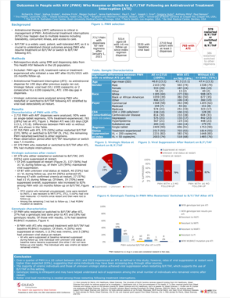  POSTER

CROI 2024
Weight Gain in People With HIV (PWH) vs People Without HIV (PWoH) Over a 3-Year Period  Authors: Richard A. Elion, Joshua Gruber, Janna Radtchenko, Paul E. Sax, Megan Dunbar, Joseph J. Eron4, Cal Cohen, Gregory Huhn, Keri N. Althoff, Grace A. McComsey  Poster presentated at: CROI; 2024 March, 3-6; Denver, CO  Online access | 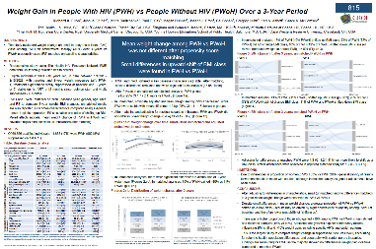  POSTER
Real-World Use of Cabotegravir Long-Acting for Pre-Exposure Prophylaxis: Trio Health Cohort  Authors: Kenneth Mayer, Carolyn Brown, Andrew Frick, Janna Radtchenko, Gayathri Sridhar, Leigh Ragone, Jean van Wyk, Anthony Mills, Steven Santiago, Richard Elion, Vani Vannappagari  Poster presentated at: CROI; 2024 March, 3-6; Denver, CO  Online access | 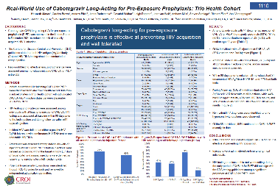  POSTER
Real-World Utilization of Cabotegravir + Rilpivirine in the US: Data From Trio Health Cohort  Authors: Joseph J. Eron, Supriya Sarkar, Andrew Frick, Janna Radtchenko, Gayathri Sridhar, Leigh Ragone, Karam Mounzer, Steven Santiago, Jean van Wyk, Richard Elion, Vani Vannappagari  Poster presentated at: CROI; 2024 March, 3-6; Denver, CO  Online access | 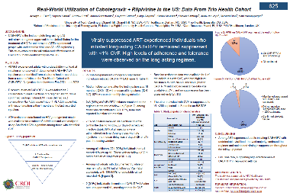  POSTER

IDWeek 2023
Real-World Utilization and Effectiveness of Long-Acting Cabotegravir + Rilpivirine in the United States: Trio Cohort Study  Authors: Richard A. Elion, Andrew Frick, Janna Radtchenko, Supriya Sarkar, Gayathri Sridhar, Joseph J. Eron, Karam Mounzer, Jean Van Wyk, Vani Vannappagari  Poster presented at: IDWeek 2023 October 11-15; Boston, Massachusetts | 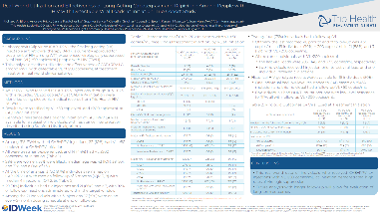  POSTER
Exploring Antiretroviral Therapy (ART) Switch Decisions in Clinical Setting: Trio Health Mixed Methods Study  Authors: Rick Elion, Megan Dunbar, K Rivet Amico, Joshua Gruber, Lauren Harrison, Grace McComsey, Peter Shalit, Janna Radtchenko  Poster presented at: IDWeek 2023 October 11-15; Boston, Massachusetts | 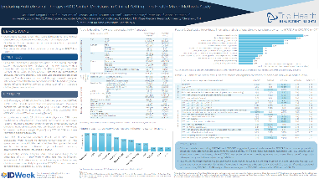  POSTER

12th Annual International AIDS Society Conference on HIV Science (IAS) 2023
Real-World Utilization and Effectiveness of Long-Acting Cabotegravir + Rilpivirine in the United States: Trio Cohort Study  Authors: R. Elion, S. Sarkar, J. Radtchenko, A. Frick, G. Sridhar, J.J. Eron, J.C. Gathe Jr., S. Santiago, J. Van Wyk, V. Vannappagari  Online Access  Poster presented at: 12th Annual International AIDS Society Conference on HIV Science July 23-26, 2023 Brisbane, Australia |  |  | 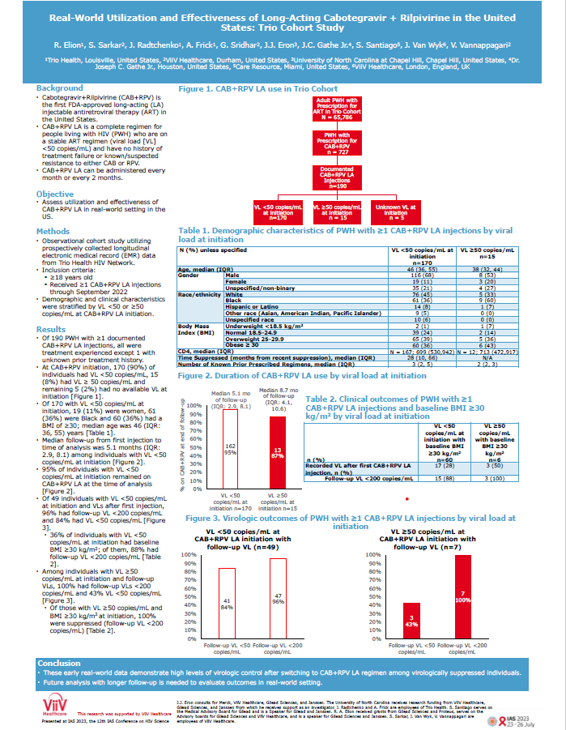  POSTER

International Workshop on HIV and Hepatitis Observational Databases (IWHOD) 2023
Predictors of Switching to DTG/3TC vs B/F/TAF in US Clinical Practice  Authors: Joshua Gruber, Megan Dunbar, Janna Radtchenko, Moshe Fridman, and Richard A. Elion  Poster presented at: 25th International Workshop on HIV and Hepatitis Observational Databases 2023. 2023 Mar 23-25 |  |  | 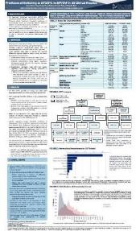  POSTER

Conference on Retroviruses and Opportunistic Infections (CROI) 2023
What Influences Switching to DTG/3TC VS B/F/TAF in Clinical Practice?  Authors: Paul E. Sax, Joseph J. Eron, Janna Radtchenko, Megan Dunbar, Joshua Gruber, Moshe Fridman, Steven Santiago, Moti Ramgopal, Karam Mounzer, Gregory Huhn, and Richard A. Elion  CROI Publications Database  Poster presented at: CROI 2023. Annual Conference on Retroviruses and Opportunistic Infections; 2023 Feb 19-22 |  |  | 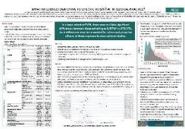  POSTER

HIV Glasgow 2022
Prescription Adherence and Persistence on Oral Pre-exposure Prophylaxis (PrEP) Among Prep-Naive (PN) Individuals After FTC/TAF Approval in the United States (US)  Authors: Richard A. Elion, Joshua Gruber, Janna Radtchenko, Megan Dunbar, Kenneth H. Mayer, Gregory Huhn, Karam Mounzer, and Anthony Mills  DOI: 10.1002/jia2.26009: P009  Poster presented at: HIV Glasgow 2022. 2022 October 23-26; Published in Journal of the International AIDS Society and Glasgow |  |  | 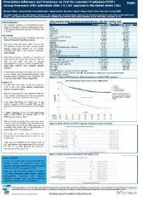  POSTER
Characteristics of Heavily Treatment Experienced (HTE) People with HIV (PWH) in US Clinical Practice  Authors: Joseph J Eron, Megan S Dunbar, Janna Radtchenko, Joshua Gruber, Gregory Huhn, Grace A McComsey, Lauren Temme, and Richard A. Elion  DOI: 10.1002/jia2.26009: P092  Poster presented at: HIV Glasgow 2022. 2022 October 23-26; Published in Journal of the International AIDS Society and Glasgow site |  |  | 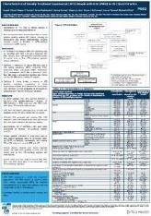  POSTER

IDWeek 2022
Prescription Adherence and Persistence on Oral Pre-exposure Prophylaxis (PrEP) Among PrEP-Naive (PN) Individuals After FTC/TAF Approval in the United States (US)  Authors: Richard A. Elion, Joshua Gruber, Janna Radtchenko, Megan Dunbar, Kenneth H. Mayer, Gregory Huhn, Karam Mounzer, and Anthony Mills  ID Week; 2022 October 19-23: Poster 2087  Poster presented at: IDWeek 2022. 2022 October 19-23; Published in IDWeek site |  |  | 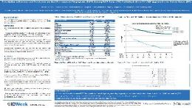  POSTER

International AIDS Conference 2022
Utilization of Oral Pre-exposure Prophylaxis (PrEP) After FTC/TAF Approval in the United States  Authors: Richard A. Elion, Joshua Gruber, Janna Radtchenko, Megan Dunbar, Kenneth H. Mayer, Gregory Huhn, and Karam Mounzer  24th International AIDS Conference; 2022 July 29-August 2: EPC332  Poster presented at: The 24th International AIDS Conference; 2022 July 29- August 2; Montreal, Canada, and virtually |  |  | 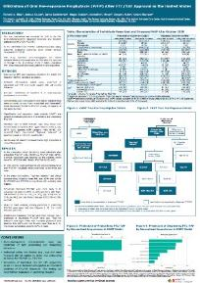  POSTER

IDWeek 2021 – VIRTUAL
Virologic Failure Among Treatment-Experienced Suppressed People with HIV (PWH) Treated with Single-Tablet 2-Drug (2DR) VS 3-Drug (3DR) Regimens  Authors: Paul E. Sax, Joseph J. Eron, Janna Radtchenko, Helena Diaz-Cuervo, Mark Moore, Steven Santiago, Moti Ramgopal, Karam Mounzer, and Richard A. Elion  ID Week Virtual; 2021 September 29- October 3  Oral presented at: IDWeek 2021 VIRTUAL. 2021 September 29- October 3; Published in IDWeek site |  |  | 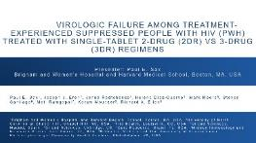  ORAL PRESENTATION

The American Conference For The Treatment Of HIV (ACTHIV) 2021 – VIRTUAL
Variables Associated with Lack of Suppression on Antiretroviral Therapy (ART) Among People Living with Human Immunodeficiency Virus (PLWH) in the US  Authors: Richard A Elion, MD, Joe J Eron, MD, Julie Priest, MSPH, Janna Radtchenko, MBA, Moti Rampogal, MD, Alan Oglesby, MPH, and M Keith Rawlings, MD  ACTHIV Presentation s Database  ePoster presented at: Virtual ACTHIV 2021 Conference. 2021 May 20-22. Abstract was also published in The NMA Journal- 112 (5 Supplement) (pp S25), October 2020 |  |  | 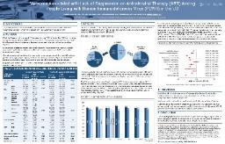  POSTER

International Society for Pharmacoeconomics and Outcomes Research (ISPOR) 2021 – VIRTUAL
Understanding Real-World Utilization of Pre-Exposure Prophylaxis (PrEP): Data from Trio Health HIV Research Network  Authors: Janna Radtchenko, MBA, and Rick Elion, MD  DOI: 10.1016/j.jval.2021.04.1268  ePoster presented at: Virtual ISPOR 2021 Conference. 2021 May 17-20. Published in Value in Health and ISPOR site |  |  | 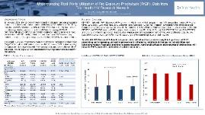  POSTER

Conference on Retroviruses and Opportunistic Infections (CROI) 2021- VIRTUAL
Weight Gain After Switching Different Integrase Strand Transfer Inhibitors (INSTI)  Authors: Grace A. McComsey, MD, Paul E. Sax, Keri N. Althoff, Janna Radtchenko, Helena Diaz-Cuervo, Joshua Gruber, Moti Ramgopal, Steven Santiago, Graeme Moyle, Karam Mounzer, and Richard A. Elion  CROI 2021 Abstract eBook: Page 190-#503  Oral presented at: VIRTUAL CROI 2021. Annual Conference on Retroviruses and Opportunistic Infections; 2021 Mar 6-10 |  |  | 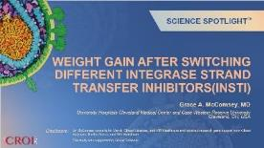  ORAL PRESENTATION

IDWeek 2020 – VIRTUAL
Regional and Racial Disparities in Response to Antiretroviral Therapy (ART) Among People Living with Human Immunodeficiency Virus (PLWH)  Authors: M Keith Rawlings, MD Additional Authors: Joe J Eron, MD, Julie Priest, MSPH, Janna Radtchenko, MBA, Joe Mrus, MD, Moti Ramgopal, MD, Alan Oglesby, MPH, Faith Fletcher, PhD, and Richard A Elion, MD  ID Week Virtual; 2020 October 21-25: 1704  Poster presented at: IDWeek 2020 VIRTUAL. 2020 October 21-25; Published in Open Forum Infectious Diseases and IDWeek site |  |  | 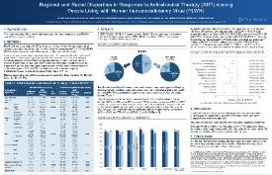  POSTER
Weight Change in Suppressed People with HIV (PWH) Switched from Either Tenofovir Disoproxil Fumarate (TDF) or Abacavir (ABC) to Tenofovir Alafenamide (TAF)  Authors: Grace A. McComsey, Paul E. Sax, Keri N. Althoff, Todd T. Brown, Janna Radtchenko, Helena Diaz-Cuervo, Moti Ramgopal, Steven Santiago, Graeme Moyle, Karam Mounzer, and Richard A. Elion  ID Week Virtual; 2020 October 21-25: LB-7  Oral presented at: IDWeek 2020 VIRTUAL. 2020 October 21-25; Published in Open Forum Infectious Diseases and IDWeek site |  |  | 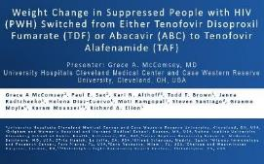  ORAL PRESENTATION

HIV Glasgow 2020 - VIRTUAL
Impact of Adherence on Viral Suppression with Bictegravir and Dolutegravir (DTG)- Containing Triple Therapy in Clinical Practice  Authors: Paul E. Sax, Keri N. Althoff, Joseph J. Eron, Janna Radtchenko, Helena Diaz-Cuervo, Karam Mounzer, Moti Ramgopal, Steven Santiago, and Richard A. Elion  DOI: 10.1002/jia.2.25616: P029  Poster presented at: HIV Glasgow VIRTUAL. 2020 October 5-8; Published in Journal of the International AIDS Society and Glasgow site |  |  | 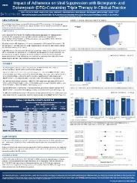  POSTER

International AIDS Conference (IAS) 2020 – VIRTUAL
Characteristics of Patients Living With HIV (PLWH) and HIV Treatment Outcomes in Community Practices in Southern Vs Non-Southern US Regions  Authors: Keith Rawlings, MD, Paul Sax, MD, Julie Priest MSPH, Janna Radtchenko, MBA, Joe Mrus, MD, Joe Eron, MD, Alan Oglesby, MPH, Keri Althoff, PhD, Faith Fletcher, PhD, Moti Ramgopal, MD, Steven Santiago, MD, Richard A Elion, MD  23rd International AIDS Conference Virtual; 2020 July 6-10: PEB0354  Poster presented at: VIRTUAL 23rd International AIDS Conference; 2020 July 6-10 |  |  | 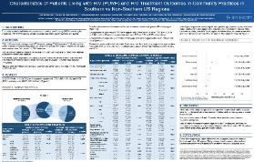  POSTER

International Society for Pharmacoeconomics and Outcomes Research (ISPOR) 2020- VIRTUAL
Patterns of Adherence in Bictegravir and Dolutegravir-Based Regimens  Authors: Paul E. Sax, Joseph J. Eron, Andrew Frick, Scott Milligan, Moti Ramgopal, Steven Santiago, Richard A. Elion  Value in Health. Volume 23, Supplement 1, S168, May 01, 2020  Poster presented at: VIRTUAL ISPOR 2020 May 18-20; Published in Value in Health and ISPOR site |  |  | 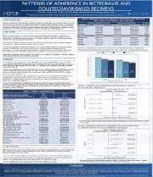  POSTER

Conference on Retroviruses and Opportunistic Infections (CROI) 2020- VIRTUAL
Patterns of Adherence in Bictegravir and Dolutegravir-Based Regimens  Authors: Paul E. Sax, Joseph J. Eron, Andrew Frick, Scott Milligan, Moti Ramgopal, Steven Santiago, and Richard A. Elion  The Conference on Retroviruses and Opportunistic Infections (CROI) Virtual; 2020 Mar 8-11: 495  Poster presented at: VIRTUAL CROI 2020. Annual Conference on Retroviruses and Opportunistic Infections; 2020 Mar 8-11 |  |  | 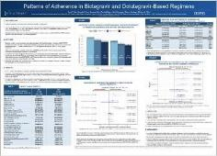  POSTER
Do Prescribing Data Reflect Actual Treatment in People With HIV?  Authors: Joseph J. Eron, Dushyantha Jayaweera, Gregory D. Huhn, Kelsey Milligan, Scott Milligan, Paul E. Sax, Keith Spitz, and Richard A. Elion  The Conference on Retroviruses and Opportunistic Infections (CROI) Virtual; 2020 Mar 8-11: 499  Poster presented at: VIRTUAL CROI 2020. Annual Conference on Retroviruses and Opportunistic Infections; 2020 Mar 8-11 |  |  | 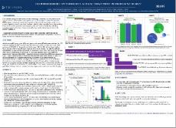  POSTER
Understanding Who Does and Does Not Gain Weight With Integrase Inhibitors (INSTI)  Authors: Grace A. McComsey, Keri N. Althoff, Todd T. Brown, Joseph J. Eron, Gregory D. Huhn, Anthony Mills, Graeme Moyle, Soodi Navadeh, Janna Radtchenko, Paul E. Sax, and Richard A. Elion  The Conference on Retroviruses and Opportunistic Infections (CROI) Virtual; 2020 Mar 8-11: 676  Poster presented at: VIRTUAL CROI 2020. Annual Conference on Retroviruses and Opportunistic Infections; 2020 Mar 8-11 |  |  | 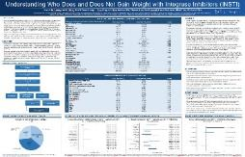  POSTER
Real-World Efficacy of Direct Acting Antiviral Therapies in Patients with HIV/HCV  Authors: Sonia Vibhakar Patel, Dushyantha T. Jayaweera‡, Keri N. Althoff, Joseph J. Eron, Janna Radtchenko, Anthony Mills, Graeme Moyle, Steven Santiago, Paul E. Sax, Jason Gillman, Karam Mounzer, Richard A. Elion, and Gregory D. Huhn DOI: 10.1371/journal.pone.0228847  Published in: PLOS ONE: February 13, 2020 |  |  | 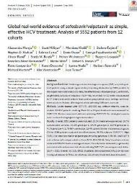  MANUSCRIPT

The European AIDS Clinical Society (EACS) 2019
Untreated HCV in HIV/HCV-Coinfected US Population Despite an Abundance of Curative Therapies  Authors: R. Elion, K. Althoff, J. Eron, J. Gillman, R. Haubrich, G. Huhn, S. Milligan, A. Mills, K. Mounzer, G. Moyle, J. Radtchenko, S. Santiago, P. Sax, and D. Jayaweera  The 17th European AIDS Clinical Society; 2019 Nov 6-9; Basel, Switzerland: PE19  Poster presented at: The 17th European AIDS Conference; 2019 Nov 6-9; Basel, Switzerland |  |  | 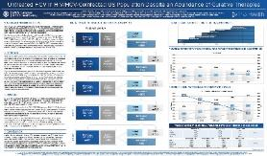  POSTER

The European Association for the Study of the Liver (EASL) 2019
Access to Direct Acting Antiviral Agents in HIV/HCV Co-Infected Population in the US  Authors: Dushyantha Jayaweera, Keri Althoff, Joseph Eron, Gregory Huhn, Janna Radtchenko, Scott Milligan, Anthony Mills, Graeme Moyle, Steven Santiago, Paul Sax, Jason Gillman, Karam Mounzer, and Rick Elion  Online Access  Poster presented at: The International Liver Congress. 54th Annual Meeting of the European Association for the Study of the Liver; 2019 Apr 10-14; Vienna, Austria |  |  | POSTER

Conference on Retroviruses and Opportunistic Infections (CROI) 2019
Weight Gain During Treatment Among 3,468 Treatment-Experienced Adults with HIV  Authors: Grace A McComsey, Joseph J Eron, Steven Santiago, Karam Mounzer, Graeme Moyle, Thanes Vanig, Paul E Sax, Keri N Althoff, Scott Milligan, Richard, Haubrich, and Richard A Elion.  The Conference on Retroviruses and Opportunistic Infections (CROI) Virtual; 2019 Mar 4-7: 671  Poster presented at: CROI 2019. Annual Conference on Retroviruses and Opportunistic Infections; 2019 Mar 4-7; Seattle, WA |  |  | 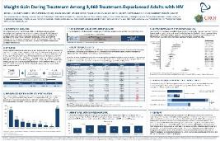  POSTER

HIV Glasgow 2018
Clinical Observations of Antiretroviral (ART) Switching in HIV- suppressed Patients After Availability of TAF  Authors: Richard Elion, Joseph Eron, Steven Santiago, Paul Sax, Moti Ramgopal, Greg Huhn, Scott Milligan, Keri Althoff, and Jonathan Winston  DOI: 10.1002/jia.2.25187: P114  Poster presented at: HIV Glasgow. 2018 October 28-31; Glasgow, UK; Published in Journal of the International AIDS Society and Glasgow site |  |  | 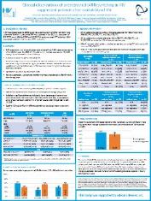  POSTER

Digestive Disease Week (DDW) 2018
Behavioral and Clinical Factors and Direct Acting Antiviral (DAA) Effectiveness in HCV/HIV Co-Infection: Clinical Experience from the TRIO Network  Authors: Rick Elion, Gregory Huhn, Dushyantha Jayaweera, Keri Althoff, Joseph Eron, Scott Milligan, Anthony Mills, Graeme Moyle, Steven Santiago, Paul Sax, Gene Voskuhl, David Wyles, and Karam Mounzer  DOI: 10.1016/S0016-5085(18)33670-9  Oral presented at: Digestive Disease Week. 2018 June 2-5; Washington, DC |  |  | 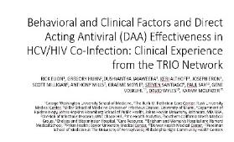  ORAL PRESENTATION
Untreated HCV in HIV/HCV Co-Infection Data from the TRIO Network  Authors: Dushyantha Jayaweera, Keri Althoff, Joseph Eron, Gregory Huhn, Scott Milligan, Anthony Mills, Graeme Moyle, Steven Santiago, Paul Sax, Gene Voskuhl, David Wyles, Karam Mounzer, and Rick Elion  DOI: 10.1016/S0016-5085(18)33931-3  Poster presented at: Digestive Disease Week. 2018 June 2-5; Washington DC |  |  | 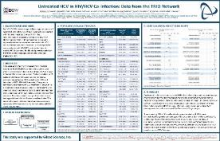  POSTER

The European Association for the Study of the Liver (EASL) 2018
Behavioral and Clinical Factors and Direct Acting Antiviral Effectiveness in HCV/HIV Co-Infection: Clinical Experience from the TRIO Network  Authors: Gregory Huhn, Dushyantha Jayaweera, Keri Althoff, Joseph Eron, Scott Milligan, Anthony Mills, Graeme Moyle, Steven Santiago, Paul Sax, Gene Voskuhl, David Wyles, Karam Mounzer, and Rick Elion  DOI: 10.1016/S0168-8278(18)30723-2  Poster presented at: The International Liver Congress. 53rd Annual Meeting of the European Association for the Study of the Liver; 2018 Apr 11-15; Paris, France |  |  | 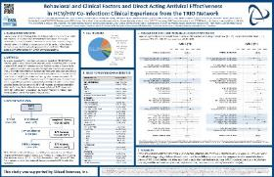  POSTER
Untreated HCV in HIV/HCV Co-Infection: Data from the TRIO Network  Authors: Dushyantha Jayaweera, Keri Althoff, Joseph Eron, Gregory Huhn, Scott Milligan, Anthony Mills, Graeme Moyle, Steven Santiago, Paul Sax, Gene Voskuhl, David Wyles, Karam Mounzer, and Rick Elion  DOI: 10.1016/S0168-8278(18)30735-9  Poster presented at: The International Liver Congress. 53rd Annual Meeting of the European Association for the Study of the Liver; 2018 Apr 11-15; Paris, France |  |  | 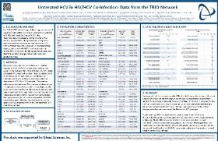  POSTER

HAE

International Society for Pharmacoeconomics and Outcomes Research (ISPOR) 2023
Barriers to Persisting on Prophylactic Treatment For C1-Esterase Inhibitor Deficient Hereditary Angioedema; Observations from Community Immunology  Authors: Jason Raasch, William R. Lumry, Scott C. Milligan, and Marc Riedl  DOI: https://doi.org/10.1016/j.jval.2023.03.2053  Poster presented at: ISPOR 2023 Conference; 2023 May 7-10; Boston, MA. Published in Value in Health and ISPOR site |  |  | 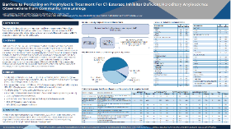  POSTER

American College of Allergy, Asthma & Immunology (ACAAI) 2022
Attack Location And Severity/Resolution In Patients With Hereditary Angioedema (HAE); Observations From Community Immunology  Authors: William R. Lumry, H. Henry Li, Scott C. Milligan, Jason Raasch, and Marc Riedl  DOI: 10.1016/j.anai.2022.08.593  Poster presented at: American College of Allergy, Asthma & Immunology- 2022 Annual Scientific Meeting, 2022 Nov 10-14; Louisville, Kentucky |  |  | 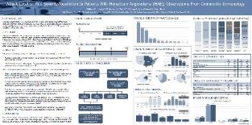  POSTER
Development Of The Patient-Important Outcomes National Data Repository (PIONEER) For Hereditary Angioedema (HAE)  Authors: William R. Lumry, Joshua Jacobs, H. Henry Li, Scott C. Milligan, Maeve E. O’Connor, Jason Raasch, and Marc Riedl  DOI: 10.1016/j.anai.2022.08.591  Poster presented at: American College of Allergy, Asthma & Immunology- 2022 Annual Scientific Meeting, 2022 Nov 10-14; Louisville, Kentucky |  |  | 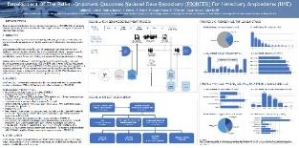  POSTER

IPF/PAH

Pulmonary Circulation Journal 2023
Characteristics of Patients with Pulmonary Arterial Hypertension from an Innovative, Comprehensive Real-World Patient Data Repository  Authors: Harrison W. Farber, Murali M. Chakinala, Michelle Cho, Robert P. Frantz, Andrew Frick, Lisa Lancaster, Scott Milligan, Ronald Oudiz, Sumeet Panjabi, Yuen Tsang, Steven D. Nathan  Pulmonary Circulation 13 (3): e12258. July 06, 2023 https://doi.org/10.1002/pul2.12258. | 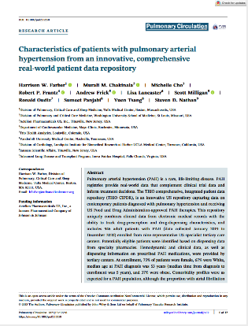  MANUSCRIPT

American Thoracic Society (ATS) 2022
Development of a Comprehensive, Integrated Patient Data Repository of US Pulmonary Hypertension (PH) Patients to Assess the Impact of Clinical Care on Patient Outcomes  Authors: H.W. Farber, S. Milligan, S. Panjabi, Y. Tsang, K. Bettencourt, and M. Cho  DOI: 10.1164/ajrccm-conference.2022.205.1_MeetingAbstracts.A3997  Poster presented at: ATS 2022 May 13-18 |  |  | 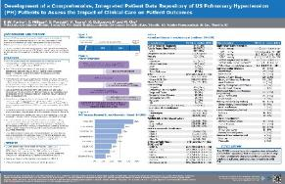  POSTER

CHEST Annual Meeting 2021 – VIRTUAL
Comparison of Idiopathic Versus Connective Tissue Disease-Associated Pulmonary Arterial Hypertension (PAH) Groups in US Clinical Practice  Authors: Ronald J. Oudiz, MD, FCCP, Murali M. Chakinala, MD, FCCP, Robert P. Frantz, MD, Adaani E. Frost, MD, Lisa H. Lancaster, MD, FCCP, Steven D. Nathan, MBBCh, FCCP, Sumeet Panjabi, PhD, Andrew Frick, MS, and Harrison W. Farber, MD  DOI: 10.1016/j.chest.2021.07.2006  ePoster presented at: Virtual CHEST 2021 Conference. 2021 October 17-20. |  |  | 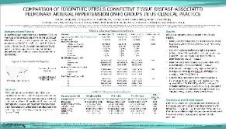  POSTER
Transthoracic Echocardiogram (ECHO) and Right Heart Catheterization (RHC) as Disease Management Tools for Patients with PAH in US Clinical Practice  Authors: Murali M. Chakinala, MD, FCCP, Robert P. Frantz, MD, Lisa H. Lancaster, MD, FCCP, Steven D. Nathan, MBBCh, FCCP, Ronald J. Oudiz, MD, FCCP, Sumeet Panjabi, PhD, Nicole Wick, and Harrison W. Farber, MD  DOI: 10.1016/j.chest.2021.07.2023  ePoster presented at: Virtual CHEST 2021 Conference. 2021 October 17-20. |  |  | 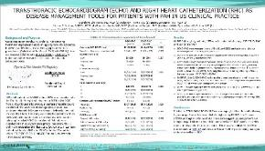  POSTER
Care and Characteristics of Patients with Pulmonary Arterial Hypertension (PAH) in US Clinical Practice  Authors: Adaani E. Frost, MD, Murali M. Chakinala, MD, FCCP, Robert P. Frantz, MD, Lisa H. Lancaster, MD, FCCP, Steven D. Nathan, MBBCh, FCCP, Ronald J. Oudiz, MD, FCCP, Sumeet Panjabi, PhD, Scott Milligan, PhD, and Harrison W. Farber, MD  DOI: 10.1016/j.chest.2021.07.1999  ePoster presented at: Virtual CHEST 2021 Conference. 2021 October 17-20. |  |  | 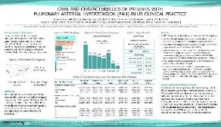  POSTER

International Society for Pharmacoeconomics and Outcomes Research (ISPOR) 2021 – VIRTUAL
Comorbid Burden and Survival Risk Metrics of Pulmonary Hypertension (PH) Patients in US-Clinical Care: Real-World Assessments from the TRIO Health PH Registry  Authors: Murali Chakinala, Deepali Rane, Ronald Oudiz, Adaani Frost, Robert Frantz, Steven Nathan, and Harrison Farber  ISPOR Presentations Database  DOI: 10.1016/j.jval.2021.04.344  ePoster presented at: Virtual ISPOR 2021 Conference. 2021 May 17-20. Published in Value in Health and ISPOR site |  |  | 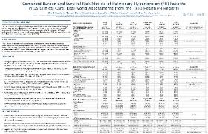  POSTER
Real-World Clinical Characteristics of 112 Patients with Interstitial Lung Disease (ILD); Update from the Trio Health ILD Registry  Authors: Frantz RP, Rane D, Nathan SD, Lancaster L, Frost AE, Chakinala MM, Oudiz RJ, and Farber HW  ISPOR Presentations Database  DOI: 10.1016/j.jval.2021.04.1099  ePoster presented at: Virtual ISPOR 2021 Conference. 2021 May 17-20. Published in Value in Health and ISPOR site |  |  | 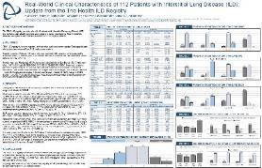  POSTER

American Thoracic Society (ATS) 2021 VIRTUAL
Comorbid Burden and Survival Risk Metrics of Pulmonary Hypertension (PH) Patients in US-Clinical Care: Real-World Assessments from the TRIO Health PH Registry  Authors: Murali Chakinala, Deepali Rane, Ronald Oudiz, Adaani Frost, Robert Frantz, Steven Nathan, and Harrison Farber  DOI: 10.1164/ajrccm-conference.2021.203.1_MeetingAbstracts.A1594  American Journal of Respiratory and Critical Care Medicine 2021; 203:A1594  ePoster presented at: ATS 2021 May 14-19 |  |  | 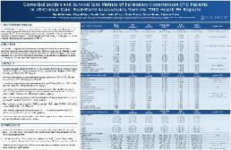  POSTER

American Thoracic Society (ATS) 2020
A Platform to Combine Clinical, Prescription, And Dispensing Data to Better Inform Idiopathic Pulmonary Fibrosis Care; The Trio Registry  Authors: Steven Nathan, MD, Murali Chakinala, MD, Robert Frantz, MD, Adaani Frost, MD, Lisa Lancaster, MD, Kelsey Milligan, Scott Milligan, PhD, Ronald Oudiz, MD, and Harrison Farber, MD  DOI: 10.1164/ajrccm-conference.2020.201.1_MeetingAbstracts.A1519  American Journal of Respiratory and Critical Care Medicine 2020; 201:A1519  Poster presented at: ATS 2020 May 15-20; Philadelphia, PA (Cancelled) |  |  |  | 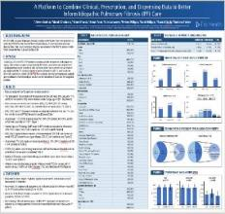  POSTER
The Trio Pulmonary Arterial Hypertension Registry; A Platform Combining EMR Clinical Measures with Pharmacy Prescription and Dispensing Data  Authors: Steven Nathan, MD, Harrison Farber, MD, Murali Chakinala, MD, Robert Frantz, MD, Adaani Frost, MD, Scott Milligan, PhD, and Ronald Oudiz, MD  DOI: 10.1164/ajrccm-conference.2020.201.1_MeetingAbstracts.A6593  American Journal of Respiratory and Critical Care Medicine 2020; 201:A6593  Poster presented at: ATS 2020 May 15-20; Philadelphia, PA (Cancelled) |  |  |  | 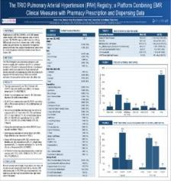  POSTER

NASH
The Fibrosis-4 Index Can Independently Predict Major Adverse Cardiovascular Events in Nonalcoholic Fatty Liver Disease  Authors: Joana Vieira Barbosa, MD, MSc, Scott Milligan, PhD, Andrew Frick, MSc, Jeremy Broestl, BSc, Zobair Younossi, MD, MPH, Nezam H. Afdhal, MD, and Michelle Lai, MD, MPH  DOI: 10.14309/ajg.0000000000001606  Published in: The American Journal of GASTROENTEROLOGY: Online January 18, 2022 |  |  |  | 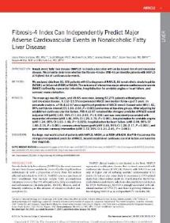  MANUSCRIPT

The American Association for the Study of Liver Diseases (AASLD) 2021 VIRTUAL
The Impact of Race on NAFLD Outcomes in US Clinical Practice  Authors: Scott B. Minchenberg, Joana Vieira Barbosa, Scott Milligan, Andrew Frick, Nezam H. Afdhal, and Michelle Lai  DOI: 10.1002/hep.32188:1747  Poster presented at: The Liver Meeting. 72nd Annual Meeting of the American Association for the Study of Liver Diseases; 2021 Nov 12-15 VIRTUAL |  |  |  | 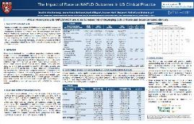  POSTER
Fibrosis-4 Index as an Independent Predictor of Mortality and Liver-Related Outcomes in NAFLD  Authors: Joana Vieira Barbosa, Scott Milligan, Andrew Frick, Jeremy Broestl, Zobair Younossi, Nezam H. Afdhal, and Michelle Lai  DOI: 10.1002/hep4.1841  Published in: Hepatology Communications: Online December 30, 2021 |  |  |  | 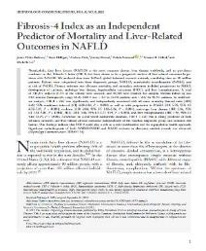  MANUSCRIPT

The American Association for the Study of Liver Diseases (AASLD) 2021 VIRTUAL
The Impact of Race on NAFLD Outcomes in US Clinical Practice  Authors: Scott B. Minchenberg, Joana Vieira Barbosa, Scott Milligan, Andrew Frick, Nezam H. Afdhal, and Michelle Lai  DOI: 10.1002/hep.32188:1747  Poster presented at: The Liver Meeting. 72nd Annual Meeting of the American Association for the Study of Liver Diseases; 2021 Nov 12-15 VIRTUAL |  |  |  | POSTER
Fibrosis-4 Index as an Independent Predictor of Mortality and Liver-Related Outcomes in NAFLD  Authors: Joana Vieira Barbosa, Scott Milligan, Andrew Frick, Jeremy Broestl, Zobair Younossi, Nezam H. Afdhal, and Michelle Lai  DOI: 10.1002/hep4.1841  Published in: Hepatology Communications: Online December 30, 2021 |  |  |  | 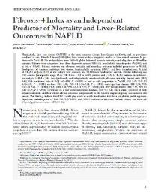  MANUSCRIPT

The European Association for the Study of the Liver (EASL) 2020 – VIRTUAL
Association of FIB4 Score with Major Cardiovascular Events (MACE) in Real-World Populations Diagnosed with NASH or NAFLD in US Clinical Practice  Authors: Michelle Lai, Jeremy Broestl, Andrew Frick, Richard Haubrich, Bruce Koch, Scott Milligan, Macky Natha, Zobair Younossi, and Nezam Afdhal  Journal of Hepatology. August 2020; 73 (suppl 1): Abstract #THU037  Poster presented at: The Digital International Liver Congress 2020; 2020 Aug 27-29 |  |  |  | 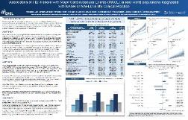  POSTER
Association of FIB4 Score with Disease Progression in Real-World Populations Diagnosed with NAFLD/NASH or at Risk of NASH in US Clinical Practice  Authors: Michelle Lai, Jeremy Broestl, Andrew Frick, Richard Haubrich, Bruce Koch, Scott Milligan, Macky Natha, Zobair Younossi, and Nezam Afdhal  Journal of Hepatology. August 2020; 73 (suppl 1): Abstract #THU036  Poster presented at: The Digital International Liver Congress 2020; 2020 Aug 27-29 |  |  |  | 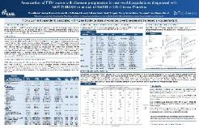  POSTER
Use of GLP-1 Receptor Agonists (GLP1a) and/or SGLT-2 Inhibitors (SGLT2i) in Populations with NASH or at Risk of NASH in US Clinical Practice  Authors: Michelle Lai, Jeremy Broestl, Kavita Juneja, Scott Milligan, Janna Radtchenko, Zobair Younossi, and Nezam Afdhal  Journal of Hepatology. August 2020; 73 (suppl 1): Abstract #FRI107  Poster presented at: The Digital International Liver Congress 2020; 2020 Aug 27-29 |  |  |  | 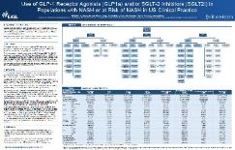  POSTER

International Society for Pharmacoeconomics and Outcomes Research (ISPOR) 2020- VIRTUAL
Evaluation of Liver Outcomes Relative to Use of GLP-1 Receptor Agonists (GLP1A) and/or SGLT-2 Inhibitors (SGLT2I) in Real-World Populations Diagnosed with Type II Diabetes (T2DM) and NASH/NAFLD or at Risk of Nash  Authors: Michelle Lai, Andrew Frick, Kavita Juneja, Bruce Koch, Scott Milligan, Macky Natha, Janna Radtchenko, Zobair Younossi, and Nezam Afdhal  DOI: 10.1016/j.jval.2020.04.365  Poster presented at: Virtual ISPOR 2020 Conference. 2020 May 15-20; Published in Value in Health and ISPOR site |  |  |  | 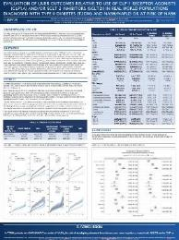  POSTER
Lean and Obese Patients with Non-Alcoholic Steatohepatitis (NASH) / Non-Alcoholic Fatty Liver Disease (NALFD); Comparisons of Populations and Disease Progression  Authors: Michelle Lai, Andrew Frick, Richard Haubrich, Bruce Koch, Scott Milligan, Macky Natha, Janna Radtchenko, Zobair Younossi, and Nezam Afdhal  DOI: 10.1016/j.jval.2020.04.363  Poster presented at: Virtual ISPOR 2020 Conference. 2020 May 15-20; Published in Value in Health and ISPOR site |  |  |  | 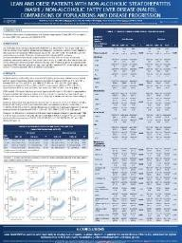  POSTER

Digestive Disease Week (DDW) 2020
Association of FIB4 Score with Major Cardiovascular Events (MACE) in Real-World Populations Diagnosed with NASH or NAFLD in US Clinical Practice  Authors: Michelle Lai, Jeremy Broestl, Andrew Frick, Richard Haubrich, Bruce Koch, Scott Milligan, Macky Natha, Zobair Younossi, and Nezam Afdhal  DOI: 10.1016/S0016-5085(20)33833-6  Oral presented online at: Digestive Disease Week. 2020 May 2-5; Chicago, IL (Cancelled) |  |  | 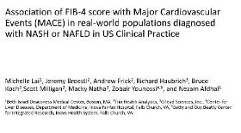  ORAL PRESENTATION
Association of FIB4 Score with Disease Progression in Real-World Populations Diagnosed with NAFLD/NASH or at Risk of NASH in US Clinical Practice  Authors: Michelle Lai, Jeremy Broestl, Andrew Frick, Richard Haubrich, Bruce Koch, Scott Milligan, Macky Natha, Zobair Younossi, and Nezam Afdhal  DOI: 10.1016/S0016-5085(20)34210-4  Poster presented at: Digestive Disease Week. 2020 May 2-5; Chicago, IL (Cancelled) |  |  | 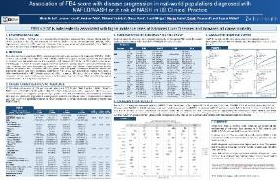  POSTER
Use of GLP-1 Receptor Agonists (GLP1a) and/or SGLT-2 Inhibitors (SGLT2i) in Populations with NASH or at Risk of NASH in US Clinical Practice  Authors: Michelle Lai, Jeremy Broestl, Kavita Juneja, Scott Milligan, Janna Radtchenko, Zobair Younossi, and Nezam Afdhal  DOI: 10.1016/S0016-5085(20)34283-9  Poster presented at: Digestive Disease Week. 2020 May 2-5; Chicago, IL (Cancelled) |  |  | 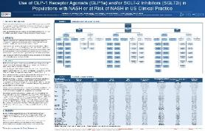  POSTER

Digestive Disease Week (DDW) 2019
Real-World Evaluation of NASH in US Clinical Practice: Underutilization of Liver Biopsy and Liver Imaging  Authors: Michelle Lai, Scott Milligan, Nicole Wick, Zobair Younossi, and Nezam Afdhal  Oral presented at: The International Liver Congress. 54th Annual Meeting of the European Association for the Study of the Liver; 2019 Apr 10-14; Vienna, Austria |  |  | 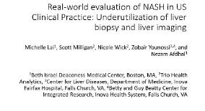  ORAL PRESENTATION

The European Association for the Study of the Liver (EASL) 2019
Real-World Evaluation of NASH in US Clinical Practice: Underutilization of Liver Biopsy and Liver Imaging  Authors: Michelle Lai, Scott Milligan, Nicole Wick, Zobair Younossi, and Nezam Afdhal.  Poster presented at: The International Liver Congress. 54th Annual Meeting of the European Association for the Study of the Liver; 2019 Apr 10-14; Vienna, Austria |  |  | 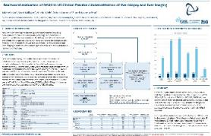  POSTER

RHEUMATOLOGY

Journal Manuscripts - Lupus Science & Medicine
Steroid-sparing effect of belimumab: results from a retrospective observational study of real-world data  Authors: Karen Worley, Scott Milligan, Bernard Rubin  DOI: 10.1136/lupus-2023-001024  Journal published in Lupus Science & Medicine 2023 Dec 22;10:e001024. doi:10.1136/ lupus-2023-001024 |  |  | 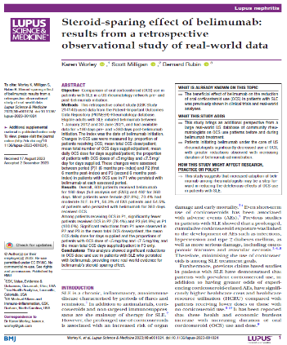  MAUNSCRIPT

American College of Rheumatology (ACR) Convergence 2023
Characteristics and Prior Treatment Journey of Systemic Lupus Erythematosus (SLE) Patients Who Were Prescribed Anifrolumab -- Observations from the American Rheumatology Network (ARN) in the U.S.  Authors: Vasileios Kyttaris, Gelareh Atefi, Dan Persons, Chris Ambrose, Scott Milligan, Sandra Sze-jung Wu  Poster presented at: ACR Convergance 2023, November 10-15; San Diego, California |  | 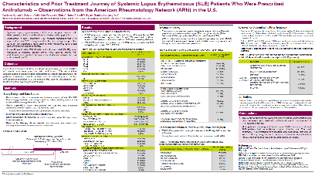  POSTER
The Effect of Belimumab on Steroid Use in Patients With SLE: Results From a Retrospective Observational Study of Real-World Data From a US Rheumatology Provider Network  Authors: Karen Worley, Scott Milligan, Bernard Rubin  Poster presented at: ACR Convergance 2023, November 10-15; San Diego, California |  | 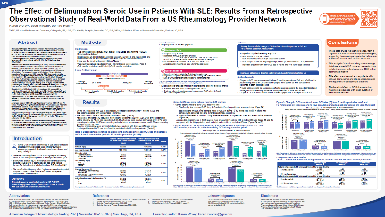  POSTER

International Society for Pharmacoeconomics and Outcomes Research (ISPOR) 2023
Reuse of Tumor Necrosis Factor Inhibitors for Treatment of Rheumatoid Arthritis despite Discordance with Patient Important Outcomes and Standard Disease Assessments  Authors: Frick A, Broestl J, Cox K, Milligan K, Persons D, Milligan S  DOI: https://doi.org/10.1016/j.jval.2023.03.092  Poster presented at: ISPOR 2023 Conference; 2023 May 7-10; Boston, MA. Published in Value in Health and ISPOR site |  |  | 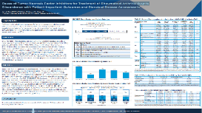  POSTER
Towards Better Rheumatoid Arthritis Management by Identification of Potentially Manageable Conditions Observed with Early Discontinuation of Biologic/Targeted Synthetic (b/ts) DMARDs  Authors: Christopher Adams, Simon Helfgott, Kent Huston, Andrew Frick, Scott Milligan, Jasvinder A. Singh, Nehad Soloman, Colin C. Edgerton  DOI: https://doi.org/10.1016/j.jval.2023.03.136  Poster presented at: ISPOR 2023 Conference; 2023 May 7-10; Boston, MA. Published in Value in Health and ISPOR site |  |  | 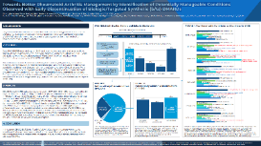  POSTER
Are Biosimilars Equivalent To Originator Molecules In The Real-World? Assessments Of Efficacy, Toxicity, And Tolerability of Infliximabs in Infliximab-Naïve Patients With Rheumatoid Arthritis  Authors: Jasvinder A. Singh, Simon Helfgott, Kent Kwas Huston, Nehad Soloman, Andrew Frick, Scott Milligan, Colin Edgerton  DOI: https://doi.org/10.1016/j.jval.2023.03.227  Poster presented at: ISPOR 2023 Conference; 2023 May 7-10; Boston, MA. Published in Value in Health and ISPOR site |  |  | 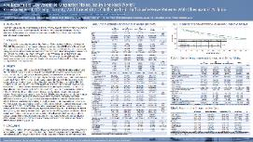  POSTER
Persistency on Conventional Synthetic DMARDS without Evidence of Rheumatoid Arthritis Control; Identifying Populations That May Benefit from Availability of Lower-Cost TNFi Biosimilars  Authors: Frick A, Broestl J, Cox K, Milligan K, Persons D, Milligan S  DOI: https://doi.org/10.1016/j.jval.2023.03.2336  Poster presented at: ISPOR 2023 Conference; 2023 May 7-10; Boston, MA. Published in Value in Health and ISPOR site |  |  | 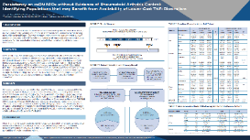  POSTER

American College of Rheumatology (ACR) Convergence 2022
Reasons For Early Discontinuation Of Targeted Synthetic (ts) Or Biologic (b) DMARDs; Chart Review of 20,343 Drug Episodes Given To Patients With Rheumatoid Arthritis  Authors: Kent Kwas Huston, Christopher Adams, Simon Helfgott, Jasvinder A. Singh, Nehad Soloman, Dan Persons, Scott Milligan, and Colin Edgerton  ACR Convergence 2022: Abstract Number: 0264  Poster presented at: ACR Convergence 2022; 2022 Nov 10-14; Philadelphia, Pennsylvania |  |  | 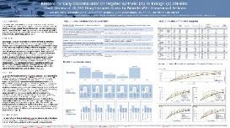  POSTER
Review of 167,990 Same day RAPID3, CDAI Scores for 61,312 Patients Receiving DMARD Treatment for Rheumatoid Arthritis; Evaluations of Disease Assessments and Treatment Discontinuation  Authors: Simon Helfgott, Kent Kwas Huston, Jasvinder A. Singh, Nehad Soloman, Andrew Frick, Scott Milligan, and Colin Edgerton  ACR Convergence 2022: Abstract Number: 0927  Poster presented at: ACR Convergence 2022; 2022 Nov 10-14; Philadelphia, Pennsylvania |  |  | 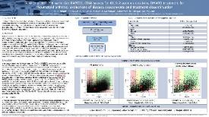  POSTER  POSTER
Development of the Patient-Important Outcomes National Data Repository (PIONEER) for Rheumatic Diseases; an Enhanced Database combining Electronic Medical Data with Insight from Chart Reviews  Authors: Simon Helfgott, Kent Kwas Huston, Jasvinder A. Singh, Nehad Soloman, Jeremy Broestl, Kimmi Cox, Kelsey Milligan, and Colin Edgerton  ACR Convergence 2022: Abstract Number: 1954  Poster presented at: ACR Convergence 2022; 2022 Nov 10-14; Philadelphia, Pennsylvania |  |  | 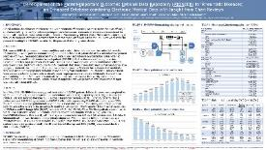  POSTER

International Society for Pharmacoeconomics and Outcomes Research (ISPOR) 2021 – VIRTUAL
Experience with Apremilast in Treatment of Psoriatic Arthritis in US Clinical Practice; Assessments from Trio Health and the American Rheumatology Network (ARN)  Authors: Colin Edgerton, Andrew Frick, Simon Helfgott, Ken Kwas Huston, Jasvinder Singh, and Nehad Soloman  DOI: 10.1016/j.jval.2021.04.1152  ePoster presented at: Virtual ISPOR 2021 Conference. 2021 May 17-20. Published in Value in Health and ISPOR site |  |  | 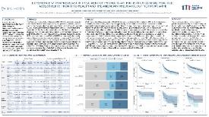  POSTER
Disparities in Targeted Immune Modulating (TIM) Treatment for Elderly Compared to Younger Patients with Psoriatic Arthritis (PSA)  Authors: Jasvinder Singh, Andrew Frick, Simon Helfgott, Kent Kwas Huston, Nehad Soloman, John Tesser, and Colin Edgerton  DOI: 10.1016/j.jval.2021.04.1154  ePoster presented at: Virtual ISPOR 2021 Conference. 2021 May 17-20. Published in Value in Health and ISPOR site |  |  | 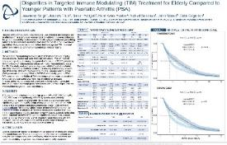  POSTER
Outcomes with Infliximab and Its Biosimilars in Patients with Rheumatoid Arthritis (RA): Real-World Experience in the US  Authors: Simon Helfgott, MD, Janna Radtchenko, MBA, Nehad Soloman, MD, Kent Kwas Huston, MD, Jasvinder Singh, MD, MPH, and Colin Edgerton, MD  ISPOR Presentations Database  DOI: 10.1016/j.jval.2021.04.075  ePoster presented at: Virtual ISPOR 2021 Conference. 2021 May 17-20. Published in Value in Health and ISPOR site |  |  | 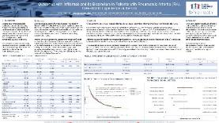  POSTER
Increasing Use of Biologics in Treatment of Systemic Lupus Erythematosus Patients in US Clinical Practice: Real-World Observations from Trio Health and the American Rheumatology Network (ARN)  Authors: Simon Helfgott, Deepali Rane, Kent Kwas Huston, Jeremy Broestl, Jasvinder Singh, Nehad Soloman, and Colin Edgerton  ISPOR Presentations Database  ePoster presented at: Virtual ISPOR 2021 Conference. 2021 May 17-20. Published in Value in Health and ISPOR site |  |  | 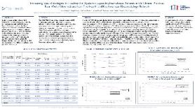  POSTER
Real-World Utilization of Janus Kinase Inhibitors (JAKs) and Biologics in Patients with Rheumatoid Arthritis (RA)  Authors: Jasvinder A. Singh, MD, MPH, Janna Radtchenko, MBA, Nehad Soloman, MD, Kwas Huston, MD, Simon M. Helfgott, MD, and Colin C. Edgerton, MD  ISPOR Presentations Database  DOI: 10.1016/j.jval.2021.04.678  ePoster presented at: Virtual ISPOR 2021 Conference. 2021 May 17-20. Published in Value in Health and ISPOR site |  |  | 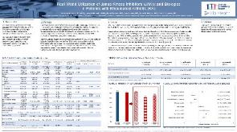  POSTER
Management of Gout with Pegloticase; Real-World Utilization and Outcomes from Trio Health and the American Rheumatology Network (ARN)  Authors: Nehad Soloman, Mona Amin, Kimmi Cox, Simon Helfgott, Alexander Hu, Kent Kwas Huston, Jordan Leonard, Scott Milligan, Jasvinder Singh, John Tesser, and Colin Edgerton  ISPOR Presentations Database  DOI: 10.1016/j.jval.2021.04.681  ePoster presented at: Virtual ISPOR 2021 Conference. 2021 May 17-20. Published in Value in Health and ISPOR site |  |  | 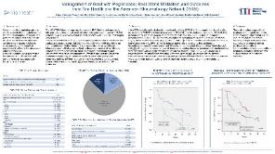  POSTER
Management of Gout after Pegloticase; Observations of US Clinical Practice from Trio Health and the American Rheumatology Network (ARN)  Authors: Nehad Soloman, Mona Amin, Simon Helfgott, Alexander Hu, Kent Kwas Huston, Jordan Leonard, Kelsey Milligan, Scott Milligan, Jasvinder Singh, John Tesser, and Colin Edgerton  ISPOR Presentations Database  DOI: 10.1016/j.jval.2021.04.682  ePoster presented at: Virtual ISPOR 2021 Conference. 2021 May 17-20. Published in Value in Health and ISPOR site |  |  | 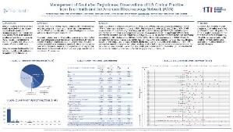  POSTER

Academy of Managed Care Pharmacy (AMCP) 2021 VIRTUAL
Real-World Utilization of Janus Kinase Inhibitors (JAKs) and Biologics in Patients with Rheumatoid Arthritis (RA)  Authors: Janna Radtchenko, Jasvinder A. Singh, MD, MPH, Nehad Soloman, MD, Kwas Huston, MD, Simon M. Helfgott, MD, and Colin C. Edgerton, MD  DOI: 10.18553/jmcp.2021.27.4-a.s1  Journal of Managed Care + Specialty Pharmacy 2021 Apr; 27(4-a Suppl): S103-M9  ePoster presented at: AMCP Managed Care and Specialty Pharmacy Annual Meeting, 2021 Apr 12-16 and published in Journal of Managed Care + Specialty Pharmacy |  |  | 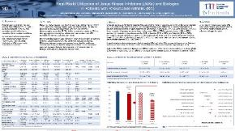  POSTER

American College of Rheumatology (ACR) Convergence 2020 - VIRTUAL
Real-World Utilization of Infliximab (IFX) and Its Biosimilars in Patients (Pts) with Rheumatoid Arthritis (RA) Since the First Biosimilar Approval in the US  Authors: Simon Helfgott, Janna Radtchenko, Nehad Soloman, Kent Kwas Huston, Jasvinder Singh, and Colin Edgerton  Arthritis Rheumatol. 2020; 72 (suppl 10)  Poster presented at: Virtual ACR Convergence 2020 Conference. 2020 Nov 5-9 |  |  | 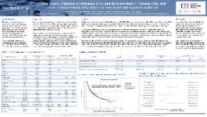  POSTER
Increasing Use of Biologics in Treatment of Systemic Lupus Erythematosus Patients in US Clinical Practice: Real-World Observations from Trio Health and the American Rheumatology Network  Authors: Simon Helfgott, Jeremy Broestl, Kent Kwas Huston, Deepali Rane, Jasvinder Singh, Nehad Soloman, and Colin Edgerton  Arthritis Rheumatol. 2020; 72 (suppl 10)  Poster presented at: Virtual ACR Convergence 2020 Conference. 2020 Nov 5-9 |  |  | 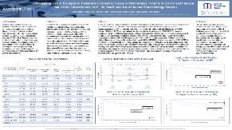  POSTER
Management of Gout After Pegloticase; Observations of US Clinical Practice from Trio Health and the American Rheumatology Network (ARN)  Authors: Nehad Soloman, Mona Amin, Simon Helfgott, Alexander Hu, Kent Kwas Huston, Jordan Leonard, Kelsey Milligan, Scott Milligan, Jasvinder Singh, John Tesser, and Colin Edgerton  Arthritis Rheumatol. 2020; 72 (suppl 10)  Poster presented at: Virtual ACR Convergence 2020 Conference. 2020 Nov 5-9 |  |  | 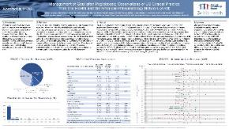  POSTER
Management of Gout with Pegloticase; Real-World Utilization and Outcomes from Trio Health and the American Rheumatology Network (ARN)  Authors: Nehad Soloman, Mona Amin, Kimmi Cox, Simon Helfgott, Alexander Hu, Kent Kwas Huston, Jordan Leonard, Scott Milligan, Jasvinder Singh, John Tesser, and Colin Edgerton  Arthritis Rheumatol. 2020; 72 (suppl 10)  Poster presented at: Virtual ACR Convergence 2020 Conference. 2020 Nov 5-9 |  |  | 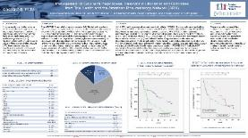  POSTER
Experience with Apremilast in Treatment of Psoriatic Arthritis in US Clinical Practice; Assessments from Trio Health and the American Rheumatology Network (ARN)  Authors: Colin Edgerton, Andrew Frick, Simon Helfgott, Kent Kwas Huston, Jasvinder Singh, and Nehad Soloman  Arthritis Rheumatol. 2020; 72 (suppl 10)  Poster presented at: Virtual ACR Convergence 2020 Conference. 2020 Nov 5-9 |  |  | 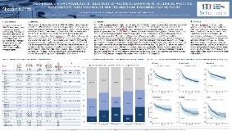  POSTER
The “Why” of Drug Discontinuation; Clinical Review of EMR Notes for 2,545 Patients with Rheumatic Diseases  Authors: Kent Kwas Huston, Simon Helfgott, Scott Milligan, Jasvinder Singh, Nehad Soloman, Brandon Weil, and Colin Edgerton  Arthritis Rheumatol. 2020; 72 (suppl 10)  Poster presented at: Virtual ACR Convergence 2020 Conference. 2020 Nov 5-9 |  |  | 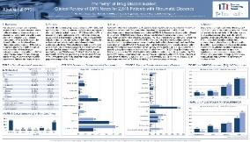  POSTER
Change in Utilization of Outpatient Services at US Community Rheumatology Practices During COVID-19 Outbreak  Authors: Kent Kwas Huston, Nehad Soloman, Janna Radtchenko, Simon Helfgott, Jasvinder Singh, and Colin Edgerton  Arthritis Rheumatol. 2020; 72 (suppl 10)  Poster presented at: Virtual ACR Convergence 2020 Conference. 2020 Nov 5-9 |  |  | 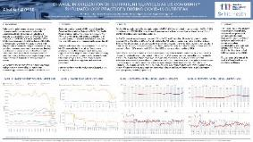  POSTER

International Society for Pharmacoeconomics and Outcomes Research (ISPOR) 2020 – VIRTUAL
Outpatient Costs in Rheumatoid Arthritis (RA) Patients With VS Without Comorbidities  Authors: Edgerton CC, Radtchenko J, and Holers VM  DOI: 10.1016/j.jval.2020.04.691  Value in Health. 2020; 23 (suppl 1): S214  Poster presented at: Virtual ISPOR 2020 Conference. 2020 May 15-20 |  |  | 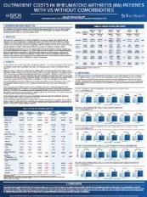  POSTER

American College of Rheumatology (ACR) 2019
Outpatient Costs and Evaluation and Management (E&M) Expenditure Trends in Rheumatoid Arthritis (RA) Patients Treated with Biologic Therapies in US Community Practices  Authors: Colin C. Edgerton, Janna Radtchenko, and V. Michael Holers  Arthritis Rheumatol. 2019; 71 (suppl 10): Abstract #1138  Poster presented at: American College of Rheumatology/ The Association of Rheumatology Professionals (ACR/ARP) Annual Meeting. 2019 November 8-13; Atlanta, GA |  | 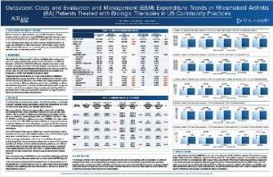  POSTER

RARE DISEASES

National Organization for Rare Disorders (NORD) 2019
Misdiagnosis of Desmoid Tumors; Insight from the Desmoid Tumor Research Foundation (DTRF) Patient Registry  Authors: Kelly Mercier, Lynn Hernandez, Vanessa Boulanger, Allison Seebald, Suzanne Rossov, and Kelsey Milligan  Poster presented at: NORD Rare Summit. 2019 October 21-22; Washington DC |  | 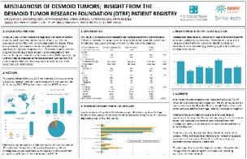  POSTER
Quality of Life in Pediatric Patients with SYNGAP1-Related Non-Syndromic Intellectual Disability (NSID); Data from the SYNGAP1 (MRD5) Patient Registry  Authors: Weldon M, Holder J, Rumbaugh G, Smith-Hicks C, Boulanger V, Seebald A, Rossov S, Milligan K  Poster presented at: NORD Rare Summit. 2019 October 21-22; Washington DC |  | 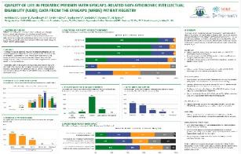  POSTER
The PKU Patient Registry: Understanding the Natural History of PKU  Authors: Olaf Bodamer MD PhD, Harvey Levy MD, Eileen Blakely, Christine Brown, Hilary Feldman, Rhonda Connolly, Kathryn Moseley, Vanessa Boulanger, Allison Seebald, Suzanne Rossov, Kelsey Milligan, and Janna Radtchenko  Poster presented at: NORD Rare Summit. 2019 October 21-22; Washington DC |  | 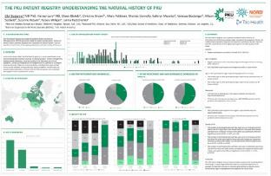  POSTER

European Hematology Association (EHA) 2019
Quality of Life and Demographics of Patients with Immune Thrombocytopenia (ITP); Data from the Platelet Disorder Support Association (PDSA) Patient Registry  Authors: Caroline Kruse, Alexandra Kruse, Nancy Potthast, Vanessa Boulanger, Allison Seebald, Suzanne Rossov and Kelsey Milligan.  DOI: 10.1097/01.HS9.0000567492.92876.8b  Poster presented at: EHA 2019. The 24th Congress of the European Hematology Association; 2019 June 13-16; Amsterdam, The Netherlands |  |  | 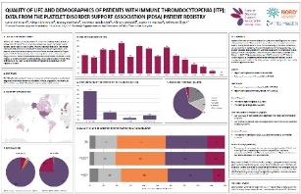  POSTER

Annual Meeting of the American Society of Clinical Oncology (ASCO) 2019
Quality of Life (QOL) and Tumor Location in Patients with Desmoid Tumors; Data From The Desmoid Tumor Research Foundation (DTRF) Natural History Study  Authors: Kelly Mercier, Lynne Hernandez, Vanessa Boulanger, Allison Seebald, Suzanne Rossov, and Kelsey Milligan  DOI: 10.1200/JCO.2019.37.15_suppl.e18291 Journal of Clinical Oncology 37, no. 15_suppl  Poster presented at: ASCO 2019. The 55th Annual Meeting of the American Society of Clinical Oncology; 2019 May 31- June 4; Chicago, Illinois |  |  | 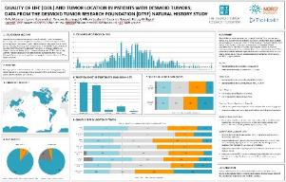  POSTER

International Society for Pharmacoeconomics and Outcomes Research (ISPOR) 2019
Understanding Disease and Burden in Syngap1-Related Non-Syndromic Intellectual Disability (NSID) Using a Patient Registry Database  Authors: Weldon M, Holder J, Rumbaugh G, Smith-Hicks C, Boulanger V, Seebald A, Rossov S, Milligan K, and Radtchenko J  DOI: 10.1016/j.jval.2019.04.1689  Poster presented at: ISPOR 2019 Conference; 2019 May 18-22; New Orleans, LA. Published in Value in Health and ISPOR site |  |  | 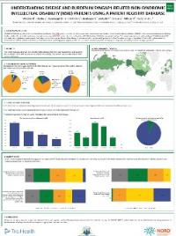  POSTER
Understanding Real-World Treatment Patterns and Quality of Life in Patients with Pemphigus and Pemphigoid Using a Patient Registry Database  Authors: Yale ML, Boulanger V, Seebald A, Rossov S, Milligan K, and Radtchenko J.  DOI: 10.1016/j.jval.2019.04.1697  Poster presented at: ISPOR 2019 Conference; 2019 May 18-22; New Orleans, LA. Published in Value in Health and ISPOR site |  |  | 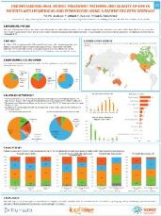  POSTER
The Use of Patient Registry to Better Inform Healthcare Decision Makers and Improve Clinical Outcomes for Patients with Phenylketonuria (PKU)  Authors: Bodamer O, Levy H, Blakely E, Brown C, Feldman H, Connolly R, and Moseley K.  DOI: 10.1016/j.jval.2019.04.1701  Poster presented at: ISPOR 2019 Conference; 2019 May 18-22; New Orleans, LA. Published in Value in Health and ISPOR site |  |  | 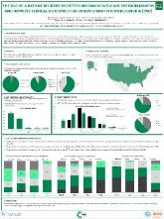  POSTER
The Use of Patient Reported Registry Data to Improve Health Outcomes for Patients with Opsoclonus Myoclonus Syndrome (OMS)  Authors: Michaelis M, Khoury-Dennis C, Boulanger V, Seebald A, Rossov S, Milligan K, and Radtchenko J.  DOI: 10.1016/j.jval.2019.04.1698  Poster presented at: ISPOR 2019 Conference; 2019 May 18-22; New Orleans, LA. Published in Value in Health and ISPOR site |  |  | 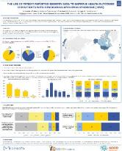  POSTER

National Institute of Health (NIH) 2019
Understanding Demographics and Diagnosis in Syngap1-related Non-Syndromic Intellectual Disability (NSID) Patients Using a Patient Registry Database  Authors: Weldon M, Holder J, Rumbaugh G, Smith-Hicks C, Boulanger V, Seebald A, Rossov K and Milligan K.  The Power of Patients: Informing Our Understanding of Rare Diseases: Posters and Acknowledgements  Poster presented at: Rare Disease Day at NIH 2019; 2019 February 28; Bethesda, MD |  |  | 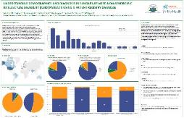  POSTER

National Organization for Rare Disorders (NORD) 2018
The Opsoclonus Myoclonus Syndrome (OMS) Registry: A Vehicle to Better Understand the Natural History and Experience of OMS Patients  Authors: Mike Michaelis, Christy Khoury-Dennis, Vanessa Boulanger, Allison Seebald, Suzanne Rossov, Scott Milligan, and Janna Radtchenko  Poster presented at: NORD Rare Summit. 2018 October 15-16; Washington DC |  |  | 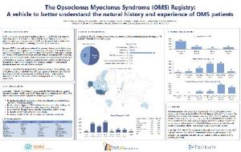  POSTER
Symptoms and Diagnosis of Opsoclonus Myoclonus Syndrome (OMS): Early Data from the OMS Registry  Authors: Mike Michaelis, Christy Khoury-Dennis, Vanessa Boulanger, Allison Seebald, Suzanne Rossov, Scott Milligan, and Janna Radtchenko  Poster presented at: NORD Rare Summit. 2018 October 15-16; Washington DC |  |  | 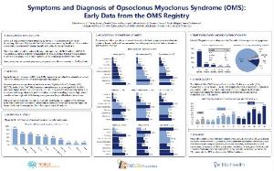  POSTER
Treatment Utilization by Patients with Opsoclonus Myoclonus Syndrome (OMS): Insights from the OMS Registry  Authors: Mike Michaelis, Christy Khoury-Dennis, Vanessa Boulanger, Allison Seebald, Suzanne Rossov, Scott Milligan, and Janna Radtchenko  Poster presented at: NORD Rare Summit. 2018 October 15-16; Washington DC |  |  | 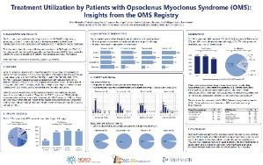  POSTER
NORD RareCare® Assistance Programs: Helping the Rare Disease Community Access Diagnostics and Care  Authors: Jill Pollander, Pamela Gavin, and Jeremy Broestl  Poster presented at: NORD Rare Summit. 2018 October 15-16; Washington DC |  |  | 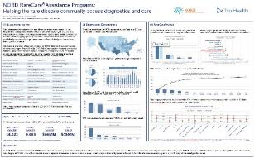  POSTER
The Pemphigus-Pemphigoid Registry: Real-World Diagnostic and Treatment Patterns  Authors: Marc L. Yale, Vanessa Boulanger, Allison Seebald, Suzanne Rossov, Scott Milligan, and Janna Radtchenko  Poster presented at: NORD Rare Summit. 2018 October 15-16; Washington DC |  |  | 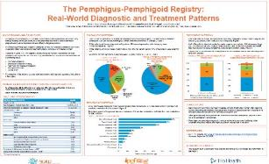  POSTER
The Pemphigus-Pemphigoid Registry: First Report of Patient Quality of Life Measures  Authors: Marc L. Yale, Vanessa Boulanger, Allison Seebald, Suzanne Rossov, Scott Milligan, and Janna Radtchenko  Poster presented at: NORD Rare Summit. 2018 October 15-16; Washington DC |  |  | 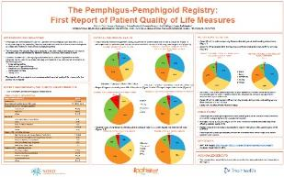  POSTER
The Pemphigus-Pemphigoid Registry: A Platform to Improve Understanding and Advance Care  Authors: Marc L. Yale, Vanessa Boulanger, Allison Seebald, Suzanne Rossov, Scott Milligan, and Janna Radtchenko  Poster presented at: NORD Rare Summit. 2018 October 15-16; Washington DC |  |  | 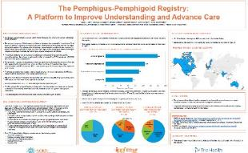  POSTER
The PKU Patient Registry: A Step for Better Disease Awareness and Improved Patient Outcomes  Authors: Eileen Blakely, Christine Brown, Olaf Bodamer, Harvey Levy, Hilary Feldman, Rhonda Connelly, Kathryn Moseley, Vanessa Boulanger, Allison Seebald, Suzanne Rossov, Scott Milligan, and Janna Radtchenko  Poster presented at: NORD Rare Summit. 2018 October 15-16; Washington DC |  |  | 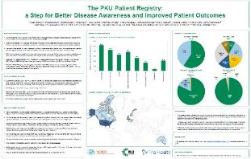  POSTER
The PKU Patient Registry: Understanding Diagnosis and Medical History of Patients with PKU  Authors: Eileen Blakely, Christine Brown, Olaf Bodamer, Harvey Levy, Hilary Feldman, Rhonda Connelly, Kathryn Moseley, Vanessa Boulanger, Allison Seebald, Suzanne Rossov, Scott Milligan and Janna Radtchenko  Poster presented at: NORD Rare Summit. 2018 October 15-16; Washington DC |  |  | 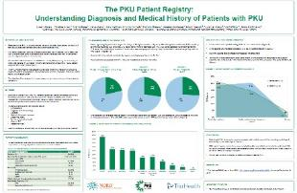  POSTER
The PKU Patient Registry: Evaluating Treatment Paradigms of Patients with PKU  Authors: Eileen Blakely, Christine Brown, Olaf Bodamer, Harvey Levy, Hilary Feldman, Rhonda Connelly, Kathryn Moseley, Vanessa Boulanger, Allison Seebald, Suzanne Rossov, Scott Milligan, and Janna Radtchenko  Poster presented at: NORD Rare Summit. 2018 October 15-16; Washington DC |  |  | 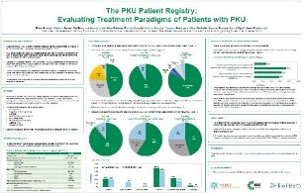  POSTER

ARTICLES
The Next Chapter for Real World Evidence: Validating Data with the Patient Voice  Tandon, Ramita  PharmaVoice (November/December 2020): Page 31 | 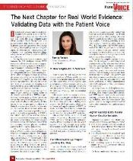
Coverage Denials Eyed in Surging HCV Rx Nonstarts  Shaw, Gina.  Specialty Pharmacy Continuum 6 (Mar/Apr 2017): Cover,15 | 